

## AMERICAN INTERNATIONAL UNIVERSITY–BANGLADESH (AIUB)

**FACULTY OF SCIENCE & TECHNOLOGY**

**DEPARTMENT OF COMPUTER SCIENCE AND ENGINEERING**

**INTRODUCTION TO DATABASE**

**FALL 2022-2023**

**Section: M, Group: 05**

**REPORT ON**

***RESTAURANT MANAGEMENT SYSTEM***

**Supervised By**

***TASNIM PARVIN***

**Submitted By**

|  |  |
| --- | --- |
| **NAME** | **ID** |
| 1. MD FAHIM AL SHIHAB (goru) | 22-46945-1 |
| 1. FATEMA AKTER TRIPTY | 22-46989-1 |

**Date of Submission:** **December, 2022**

**TABLE OF CONTENT**

|  |
| --- |
| **TOPICS                                                             Page No**    **I Title Page                                                                                   1**  **II Table of content                                                                     2** |

1. Introduction
2. Scenario
3. ER Diagram
4. Normalization
5. Finalization
6. Table Creation
7. Value Insertion
8. Query Test
9. Conclusion

**Introduction**

The topic of the project is “Restaurant Management System”. The project is designed to keep a record of the information of all branches of it and the info of all staffs those work in restaurant, the details of customers those visit the restaurant, their payment method, arrangement of items and many other things. The system helps the restaurant management to keep adequate record of all transactions carried out and does that will still be carried out by the restaurant and maintain the database of the restaurant. The main aim of this project is computerization of all processes which happen in a restaurant and also to make our project easy and simple so that it can be implemented at any level and that can be productive and useful for any restaurant administration.

**Scenario**

In a Restaurant Management System restaurant have many branches. A branch has one main restaurant. Restaurant name, code no, address, contact no and email will be stored. A staff of the restaurant will work in one branch. A branch will be worked by many staffs. The info of branches like branch id, location, contact no and email will also store. Restaurant branches will be visited by several customers. The staff information will consist of the staff name, ID, rank, contact, email and salary. The information of customers such as name, how many times a customer visit the restaurant (customer order number), contact, email and address will be stored. Customer will pay bills. Bill will be paid by the customer in two method. Customer will be able to pay the bills online and offline. Bill no, amount and date of paying will be stored. Customer will order item from item list. A customer order different kind of items. An item ordered by many customers. Item list contain item no, price, name and category. Items will be identified by category. Category will compose of Indian, Chinese, Italian, Bengali, Desserts and Drinks. There are some waiters to serve the customer. A waiter serves to many customers. A customer served by many waiters. The contact no, work time and work place of waiters will be stored. For cooking there are chefs. An item cooked by many chefs. A chef cooks different kind of items. Chefs have contact no, different work time and work place. Chef need many ingredients for cooking. An ingredient needed by many chefs. Ingredients name, price and tag no also be stored. Ingredients are delivered by supplier. A supplier delivers many ingredients. Supplier consist with supplier id, name and contact number.

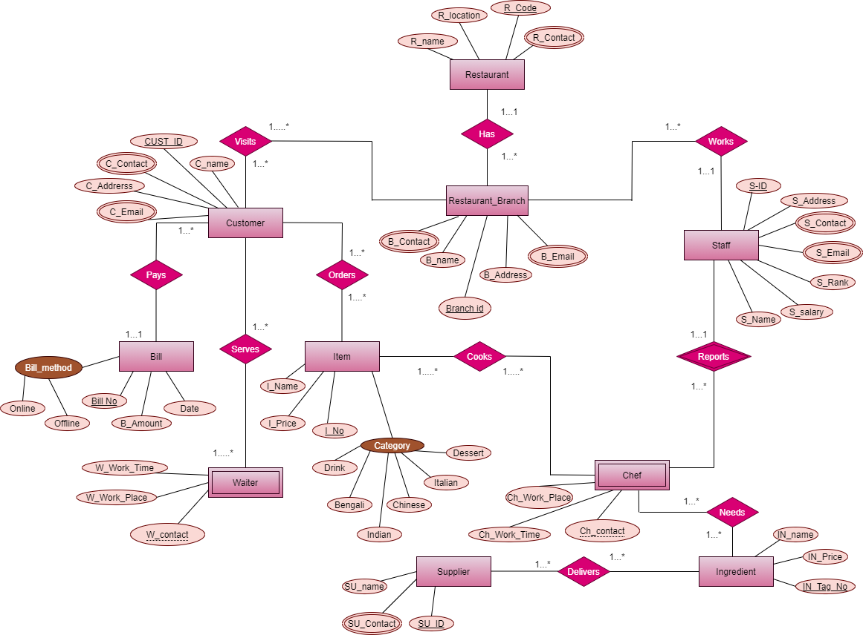**ER Diagram**

**Normalization**

**1.Has**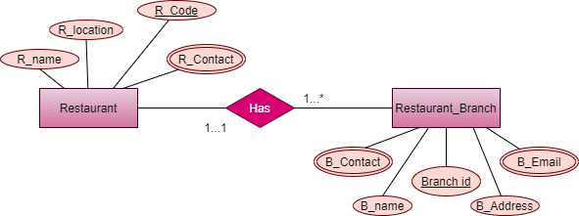

**UNF=** R_code, R_name, R_contact, R_email, Branch_ID, B_name, B_address, B_contact.

**1NF=** R_contact, R_email, B_contact, B_email are multivalued.

* R_code, R_name, R_contact, R_email, Branch_ID, B_name, B_address, B_contact.

**2NF:**

1. R_code, R_name, R_contact, R_email
2. Branch_ID, B_name, B_address, B_contact, B_email, R_code (**FK**)

**3NF=** same as 2NF

**2. Works**

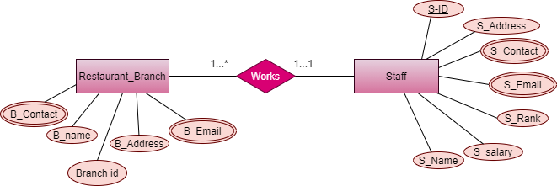

**UNF=** Branch_ID, B_name, B_address, B_contact, S_ID, S_address, S_contact, S_email, S_Rank, S_salary, S_name

**1NF=** B_contact, B_email, S_contact, S_email is multivalued.

* Branch_ID, B_name, B_address, B_contact, S_ID, S_address, S_contact, S_email, S_Rank, S_salary, S_name

**2NF=**

1. Branch_ID, B_name, B_address, B_contact, S_ID (**FK**)

2. S_ID, S_address, S_contact, S_email, S_Rank, S_salary, S_name

**3NF=** same as 2NF

**3. Reports**

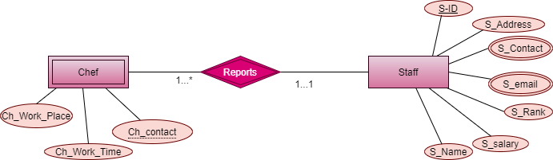

**UNF=**  S_ID , S_address, S_contact, S_email, S_Rank, S_salary, S_name, Ch_work_place, Ch_work_time, Ch_contact

**1NF=** S_contact , S_email are multivalued

* S_ID , S_address, S_contact, S_email, S_Rank, S_salary, S_name, Ch_work_place, Ch_work_time, Ch_contact

**2NF=**

1. S_ID , S_address, S_contact, S_email, S_Rank, S_salary, S_name  
 2. Ch_work_place, Ch_work_time, Ch_contact, S_ID (**FK**)

**3NF=** same as 2NF

**4. Needs**

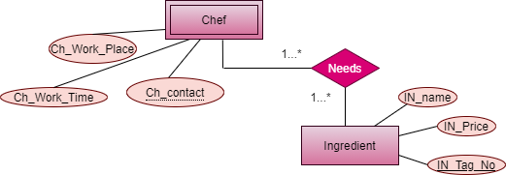

**UNF=**  Ch_work_place, Ch_work_time, Ch_contact,IN_name, IN_Price, In_Tag_No  
**1NF=** No multivalued element.

* Ch_work_place, Ch_work_time, Ch_contact,IN_name, IN_Price, In_Tag_No

**2NF=**

1. Ch_work_place, Ch_work_time, Ch_contact  
 2. IN_name, IN_Price, In_Tag_No

3. IN_Tag_No(**FK**), Ch_contact

**3NF=** same as 2NF

**5. Delivers**

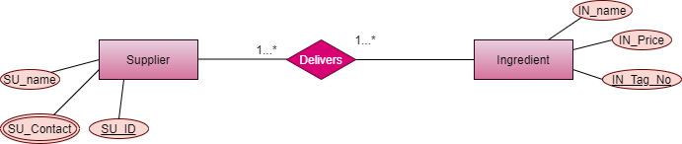

**UNF=** SU_ID, SU_name,SU_contact,IN_name, IN_Price, In_Tag_No

**1NF=** SU_contact is multivalued

* IN_name, IN_Price, In_Tag_No **,** SU_ID, SU_name,SU_contact

**2NF=**

1. IN_name, IN_Price, In_Tag_No  
 2. SU_ID, SU_name,SU_contact

3. SU_ID, In_Tag_No (FK)

**3NF=** same as 2NF

**6. Cooks**

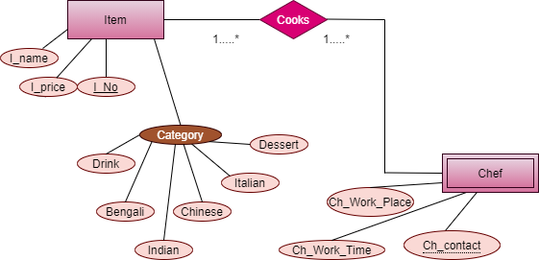

**UNF=** I_No, I_name, I_price, category, drink, dessert, Indian, Italian, Chinese, Bengali, Ch_work_place, Ch_work_time, Ch_contact

**1NF=** No multivalued element

* I_No, I_name, I_price, drink, dessert, Indian, Italian, Chinese, Bengali, Ch_work_place, Ch_work_time, Ch_contact

**2NF=**

1. I_No, I_name, I_price, drink, dessert, Indian, Italian, Chinese, Bengali  
 2. Ch_work_place, Ch_work_time, Ch_contact

3**.** Ch_contact**, I_No (FK)**

**3NF=** Same as 2NF

**7. Orders**

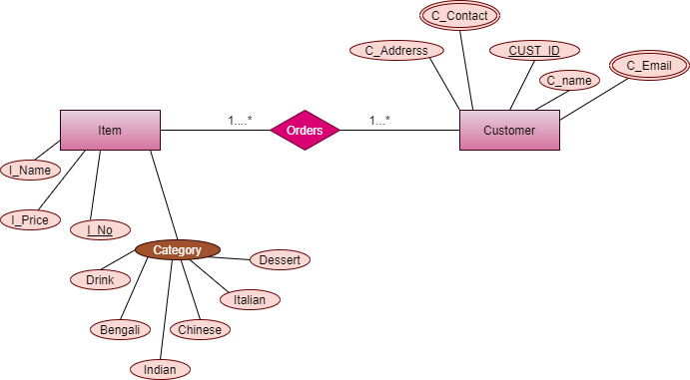

**UNF=** I_No, I_name, I_price, category, drink, dessert, Indian, Italian, Chinese, Bengali, . CUST_ID, C_name, C_address, C_contact, C_email

**1NF=** C_contact, C-email is multivalued

I_No, I_name, I_price, category, drink, dessert, Indian, Italian, Chinese, Bengali, . CUST_ID, C_name, C_address, C_contact, C_email

**2NF=**

1. I_No, I_name, I_price, category, drink, dessert, Indian, Italian, Chinese, Bengali

2. CUST_ID, C_name, C_address, C_contact, C_email  
 3. CUST_ID, I_No

**3NF=** same as 2NF

**8. Serves**

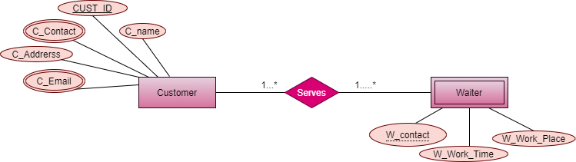

**UNF=** CUST_ID, C_name, C_address, C_contact, C_email, W_work_place, W_work_time, W_contact

**1NF=** C_contact and C_email are multivalued

* CUST_ID, C_name, C_address, C_contact, C_email, W_work_place, W_work_time, W_contact

**2NF=**

1. CUSTID, C_name, C_address, C_contact, C_email  
 2. W_contact ,W_work_place, W_work_time  
 3. CUS_TID, W_contact (**FK**)

**3NF=** same as 2NF

1. **Pays**

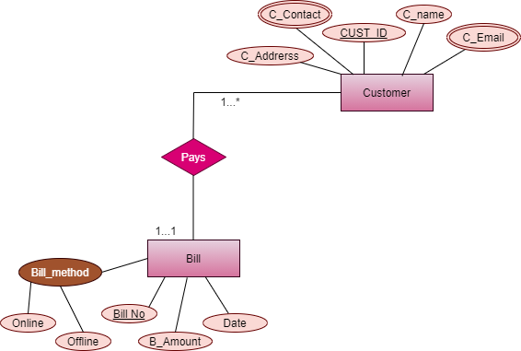

**UNF=** CUST_ID, C_name, C_address, C_contact, C_email, Bill_methode, online, offline, Bill_No, B_amount, Date

**1NF=** C_contact, C_email are multivalued

* CUST_ID, C_name, C_address, C_contact, C_email, online, offline, Bill_No, B_amount, Date

**2NF=**

1. CUST_ID, C_name, C_address, C_contact, C_email, Bill_No (**FK**)

2. Bill_No, online, offline, B_amount, Date

**3NF=** same as 2NF

**10.Visits**

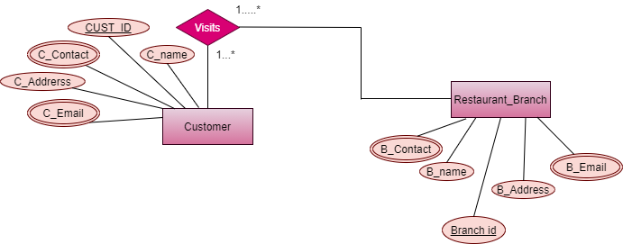

**UNF=** CUST_ID, C_name, C_address, C_contact, C_email , Branch_ID, B_name, B_address, B_contact.

**1NF=** C_contact, C_email, B_email, B_contatct are multivalued

* CUST_ID, C_name, C_address, C_contact, C_email, Branch_ID, B_name, B_address, B_contact.

**2NF=**

1. CUST_ID, C_name, C_address, C_contact, C_email

2. Branch_ID, B_name, B_address, B_contact.

3. Branch_ID , C_O_No (FK)

**3NF=** same as 2NF

**Finalization**

**Final Table:**

1.R_code, R_name, R_contact, R_email => [Restaurant]

2.Branch_ID, B_name, B_address, B_contact, B_email, R_code (**FK**) => [Branch]

3.Branch_ID, B_name, B_address, B_contact, S_ID (**FK**) => [Branch Staff]

4.S_ID , S_address, S_contact, S_email, S_Rank, S_salary, S_name => [staff Info]

5. Ch_work_place, Ch_work_time, Ch_contact

5. Ch_work_place, Ch_work_time, Ch_contact, S_ID  **=> [Chef staff]**

6. IN_name, IN_Price, In_Tag_No **=> [ Ingredient]**

7. IN_Tag_No(**FK**), Ch_contact **=> [Chef Ingredient]**

8. SU_ID, SU_name,SU_contact => **[Supplier]**

9. SU_ID, In_Tag_No (FK) => **[Ingredient Supplier]**

10. I_No, I_name, I_price, drink, dessert, Indian, Italian, Chinese, Bengali => **[Item Info]**

11**.** Ch_contact(**FK**)**, I_No => [Item Chef]**

12. CUST_ID, C_name, C_address, C_contact, C_email => **[Customer]**

13. CUST_ID (**FK**), I_No **[Item_Cust]**

14. W_contact ,W_work_place, W_work_time => **[Waiter]**

15. CUST_ID (**FK**), W_contact => **[Waiter_customer]**

16. CUST_ID, C_name, C_address, C_contact, C_email, Bill_No (**FK**) => **[Customer_Bill]**

17. Bill_No, online, offline, B_amount, Date => **[BILL]**

18. Branch_ID, B_name, B_address, B_contact. => **[ Branch M ]**

19. Branch_ID , CUST_ID (FK) => **[Branch Customer]**

**Table Creation**

**1.MAIN Restaurant Table:**

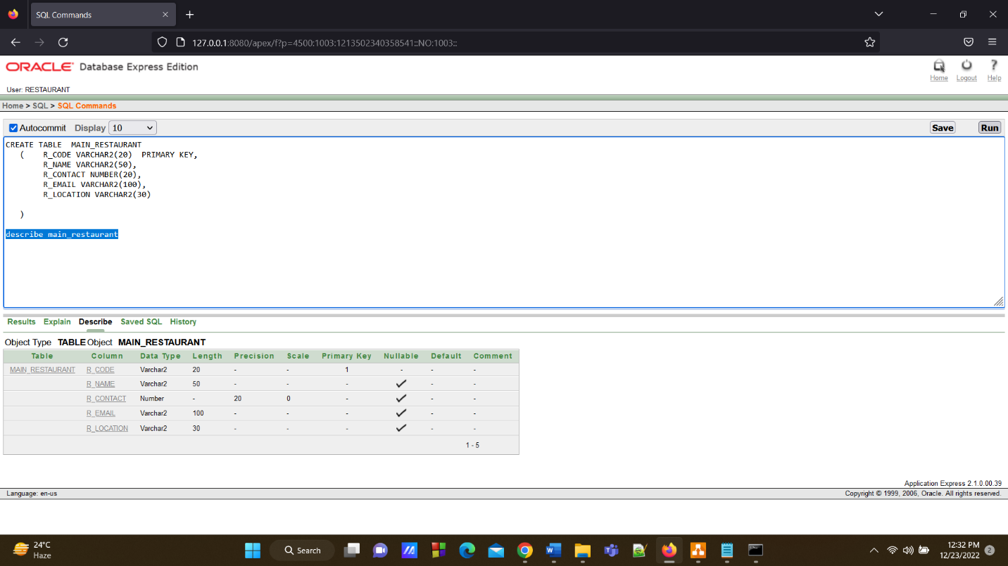

**2.Branch Table**

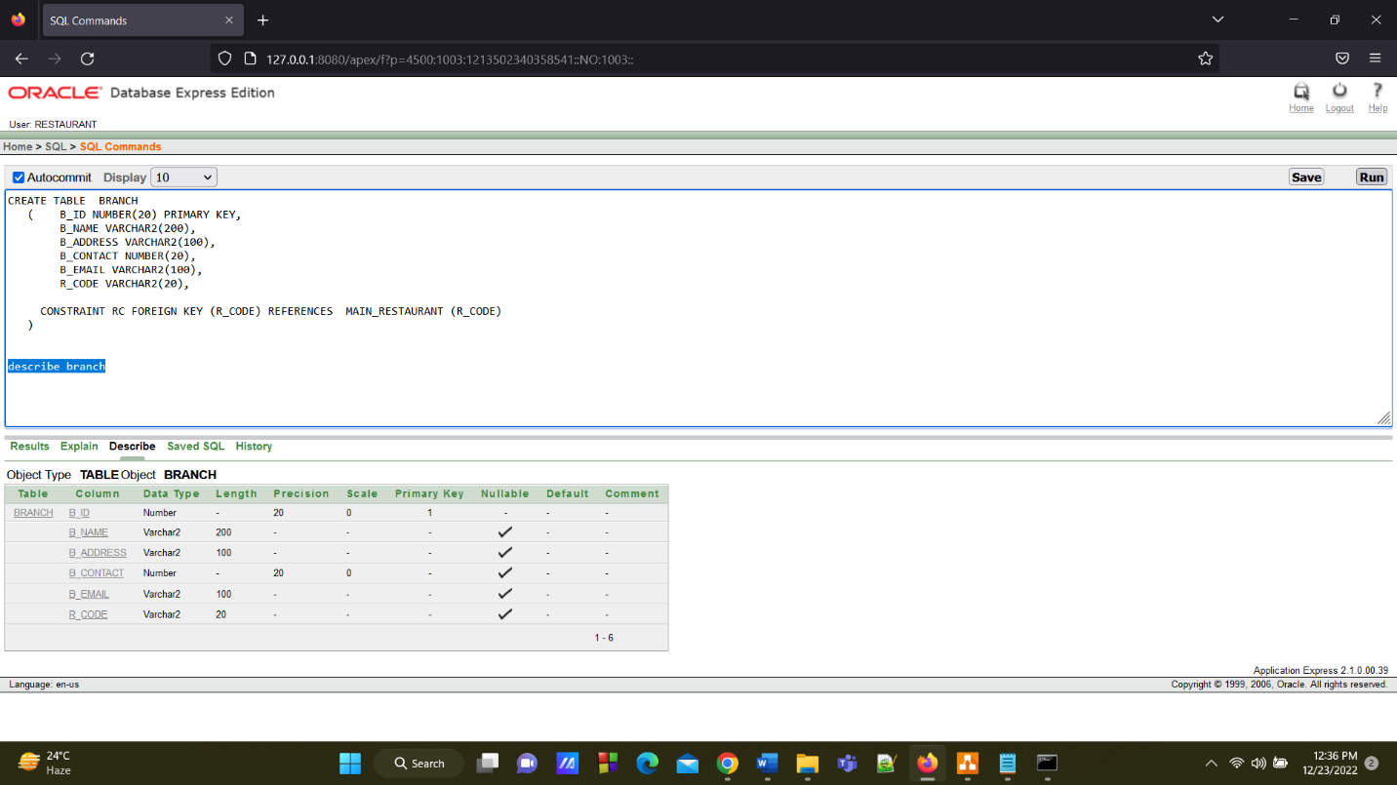

**3.Branch Staff Table**

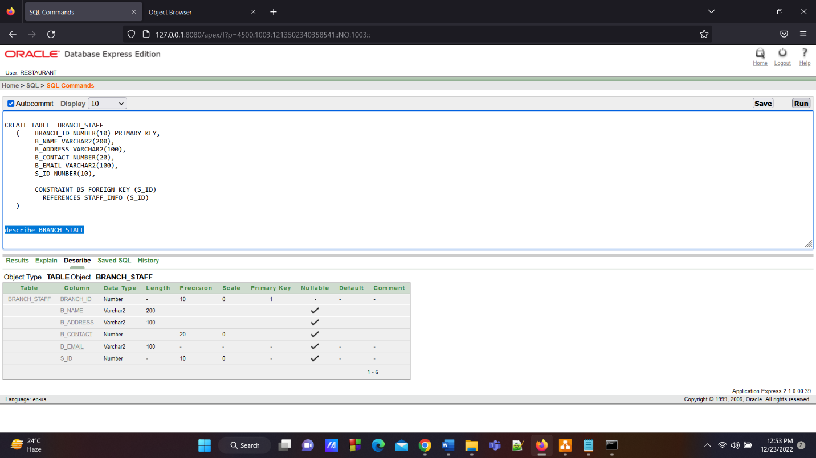

**4.Staff Info Table**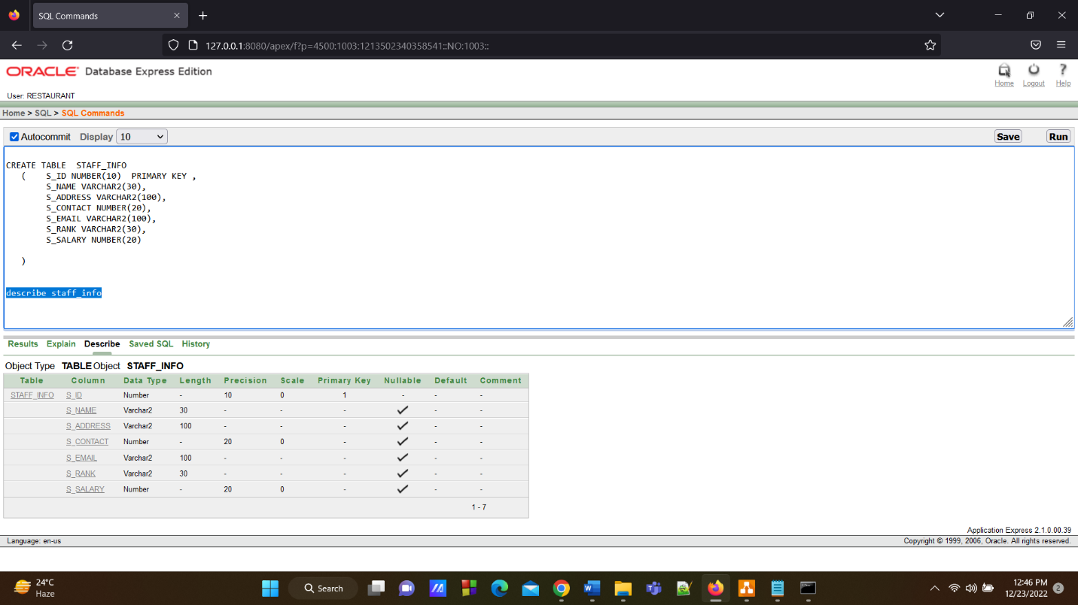

**5.Chef Info Table**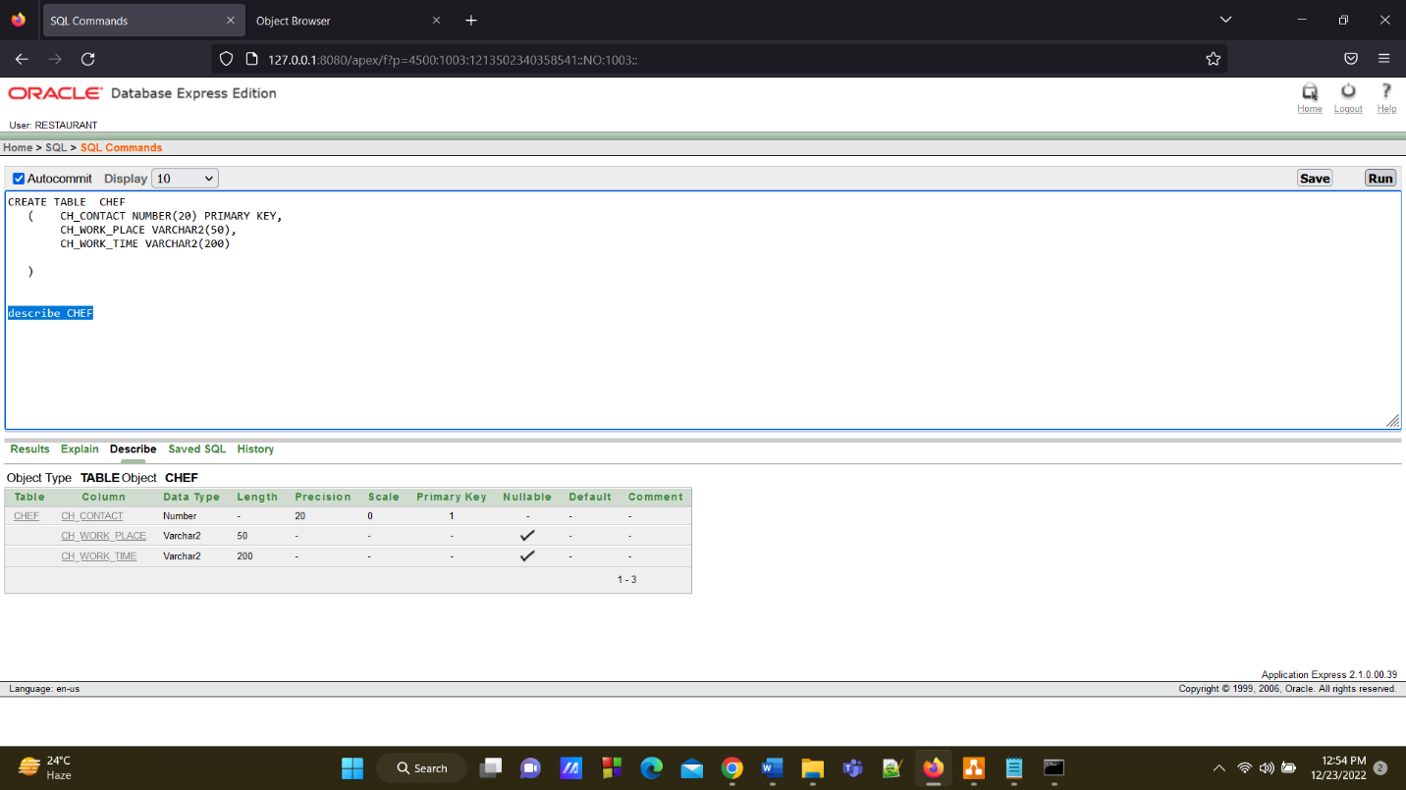

**6.Chef Staff Table**

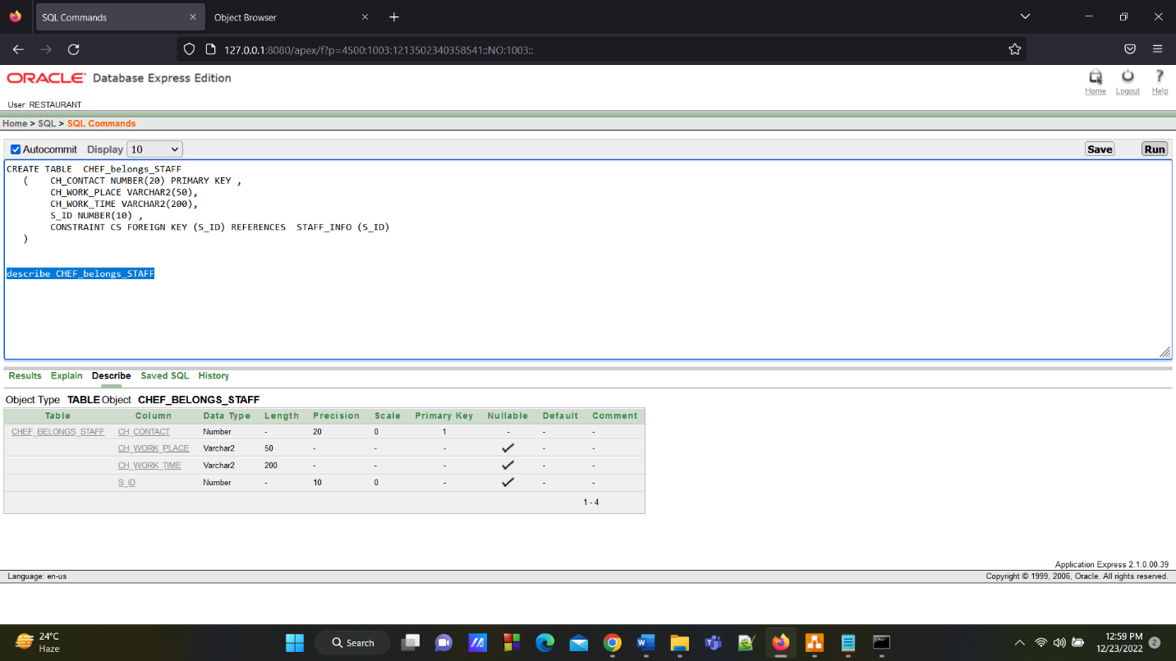

**7.Ingredient Table**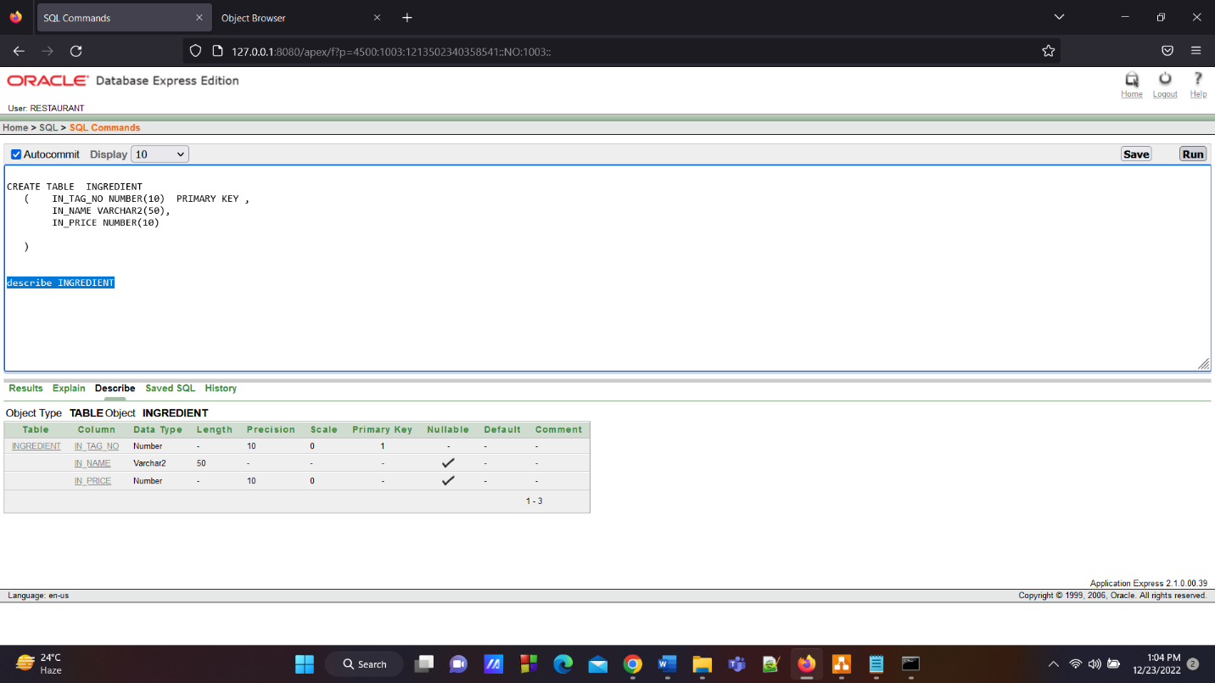

**8. Chef Ingredient Table**

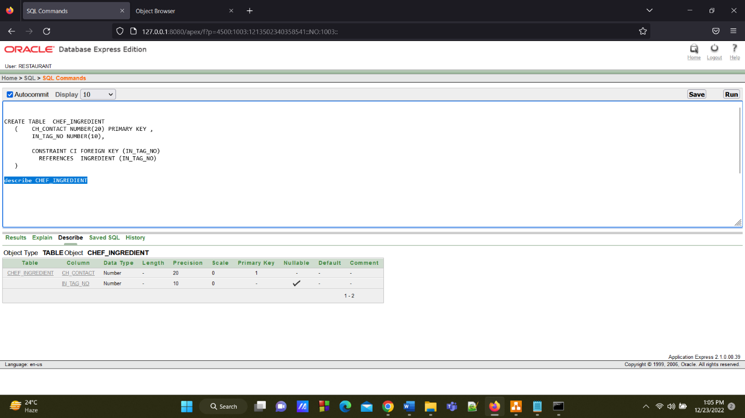

**9.Supplier Table**

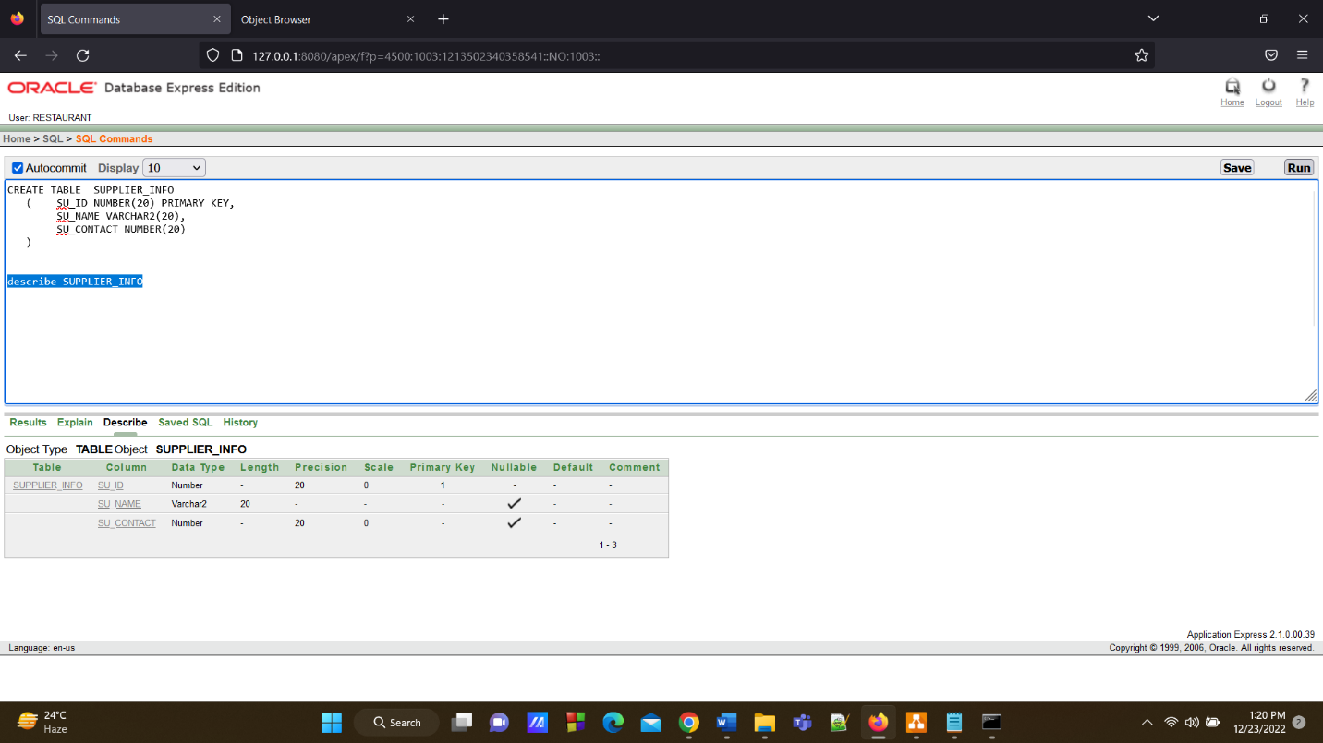

**10.Ingredient Supplier Table**

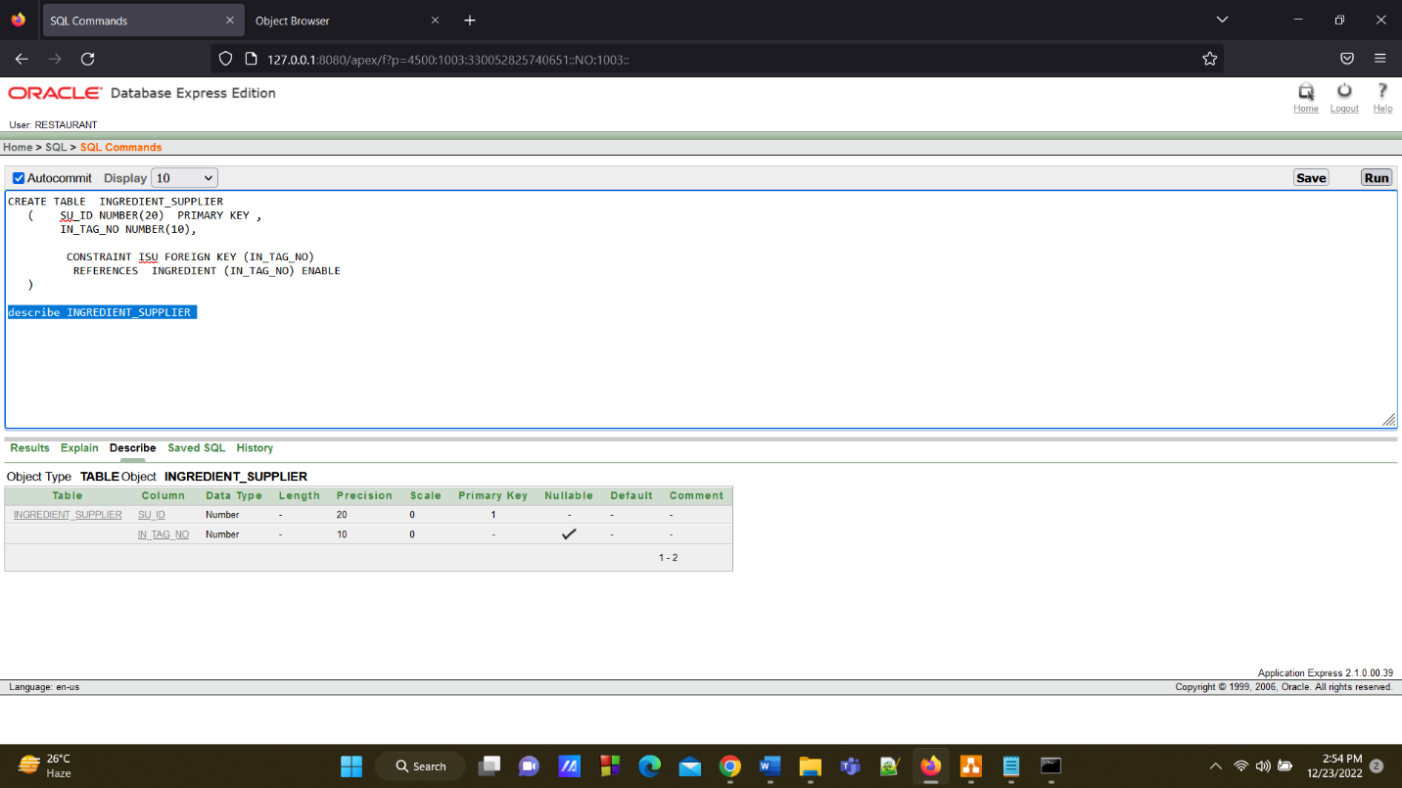

**11.Item Info Table**

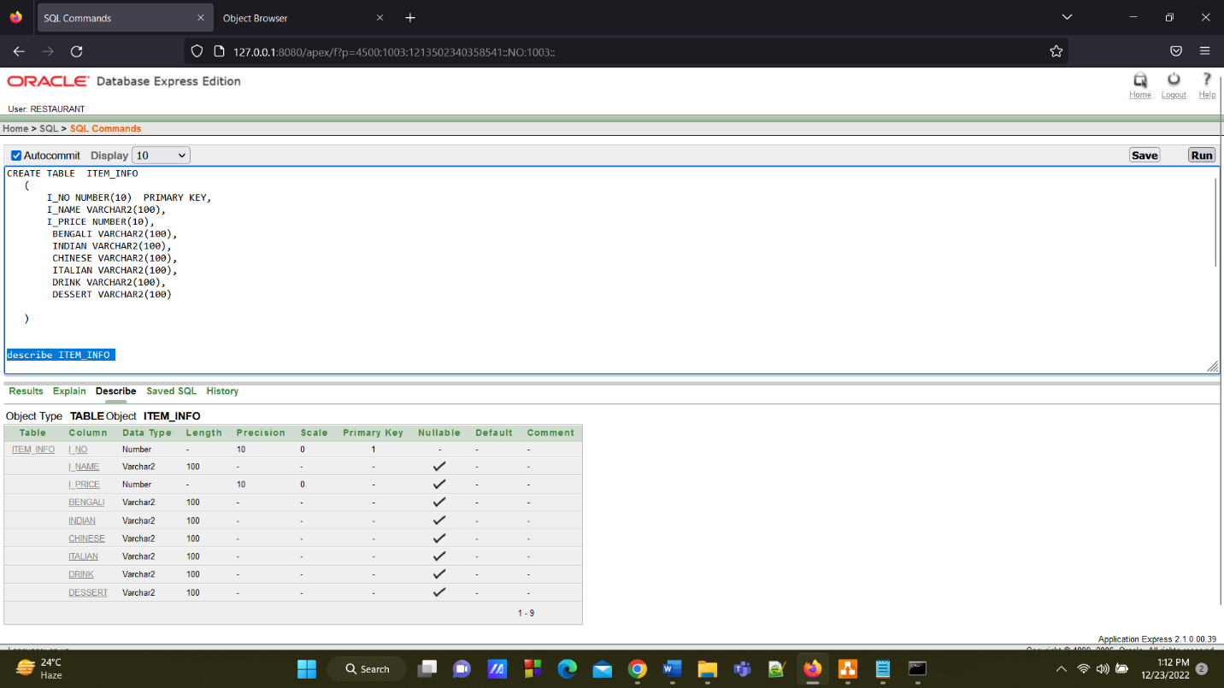

**12.Item Chef Table**

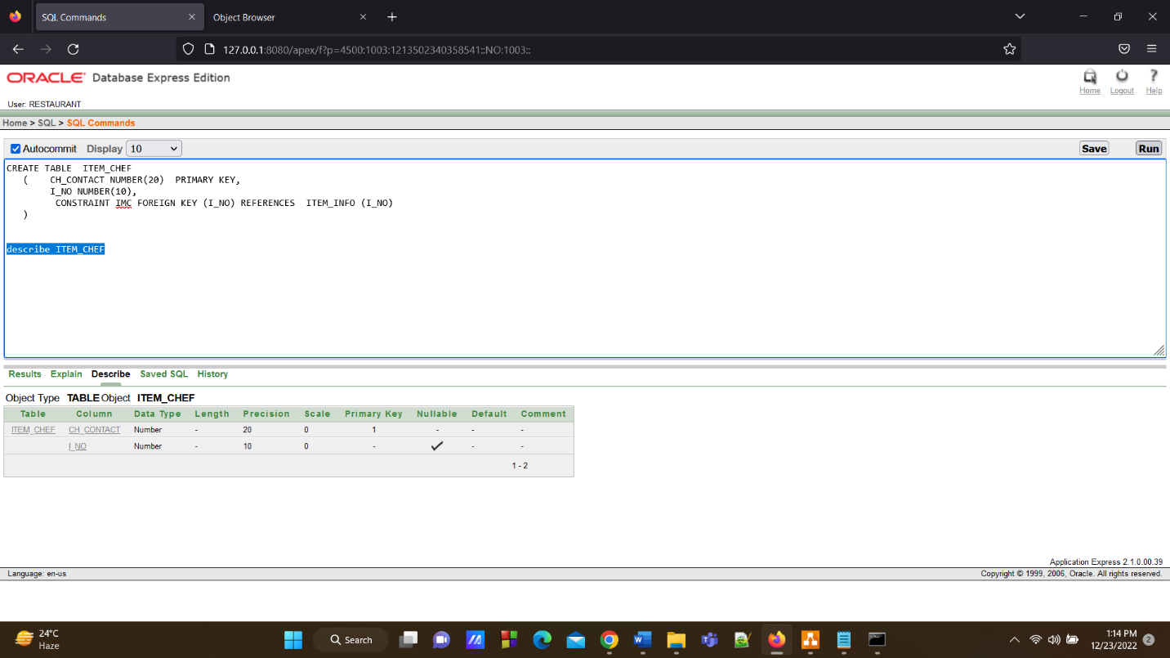

**13.Customer Table**

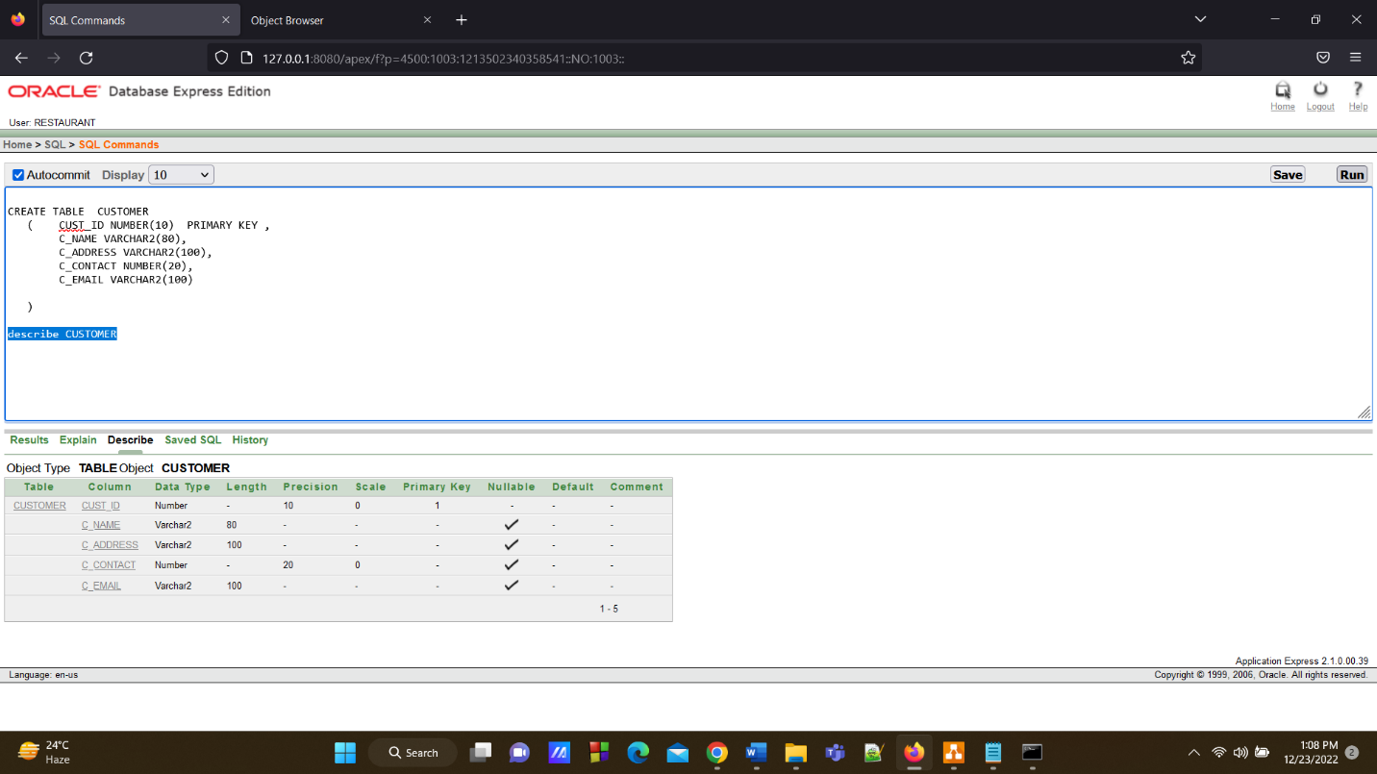

**14.Item Customer Table**

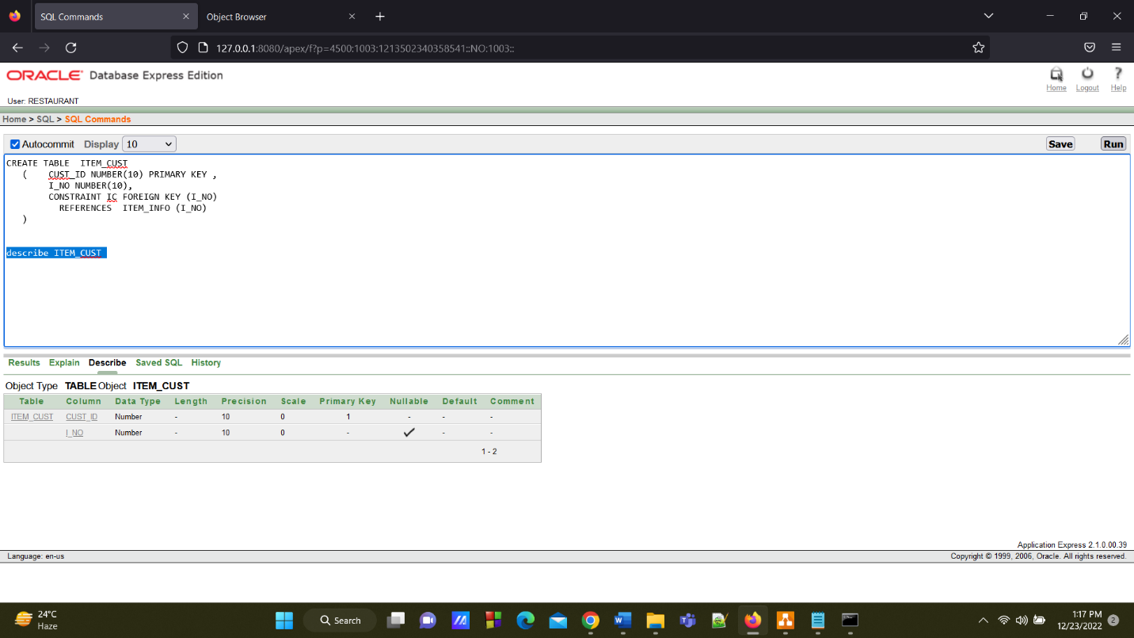

**15.Waiter Info Table**

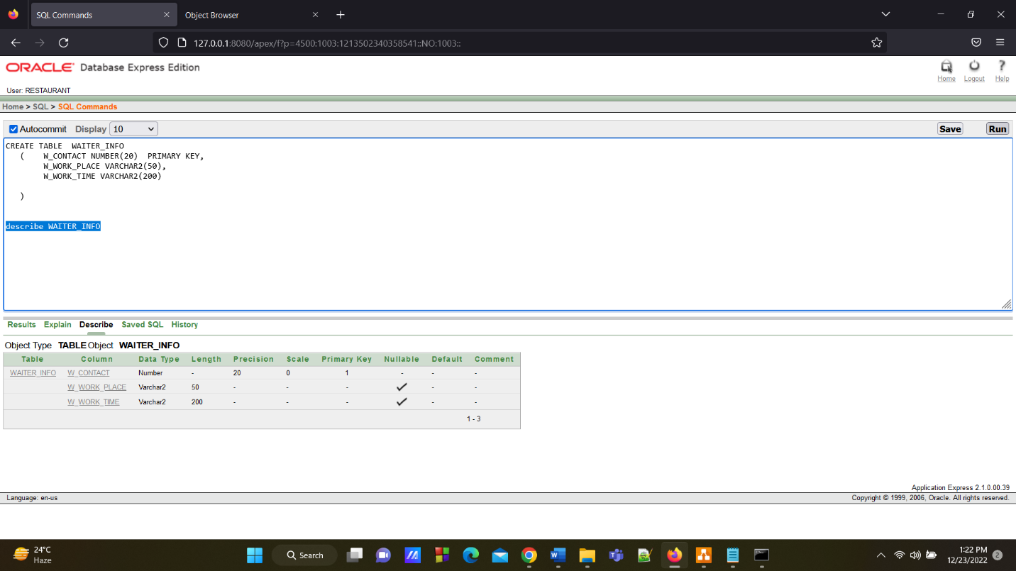

**16.Waiter Cust Table**

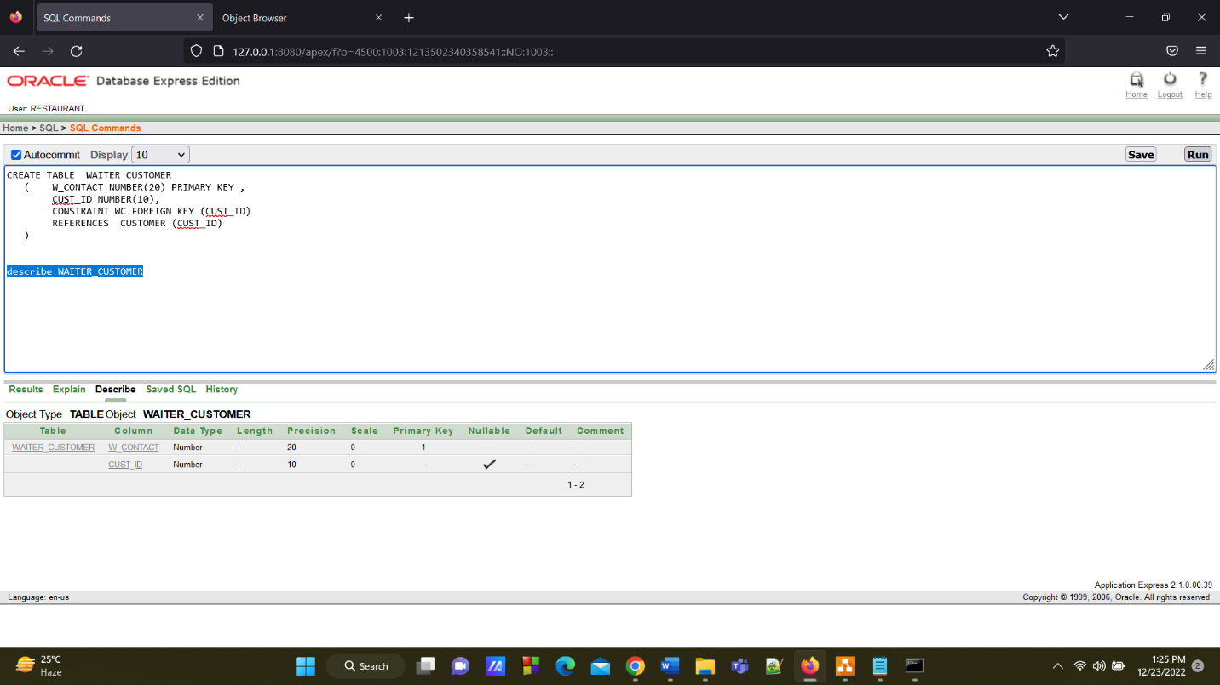

**17.Customer Bill Table**

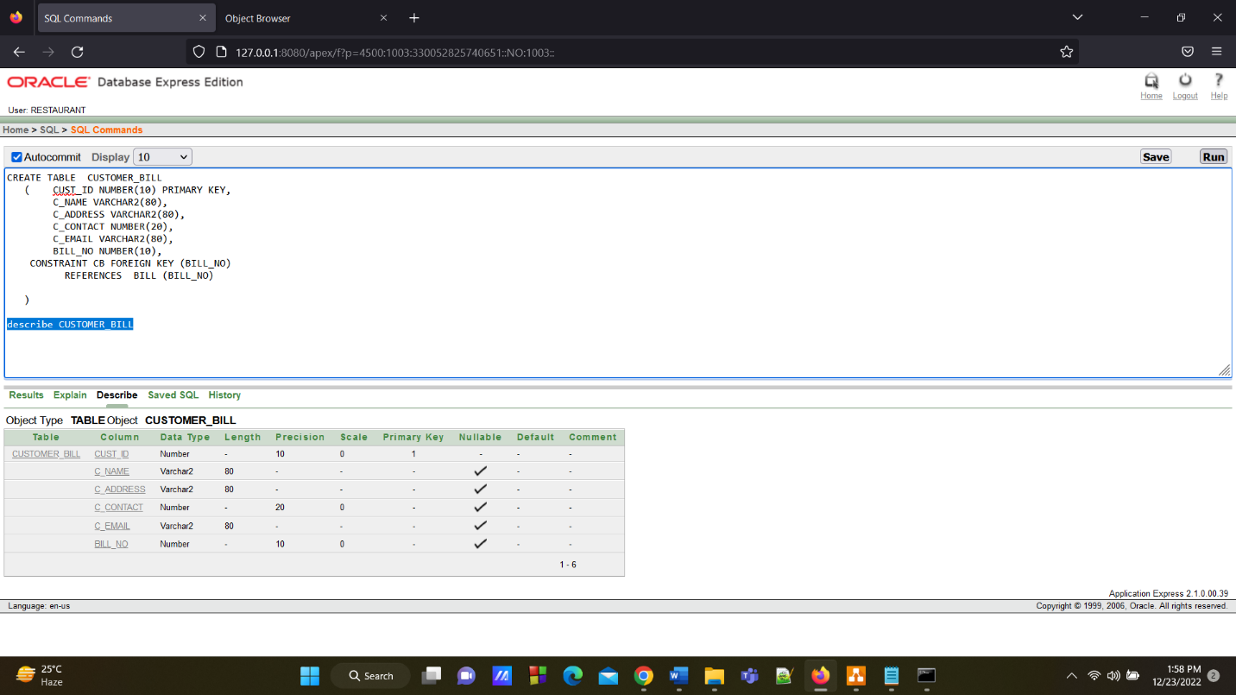

**18.Bill Table**

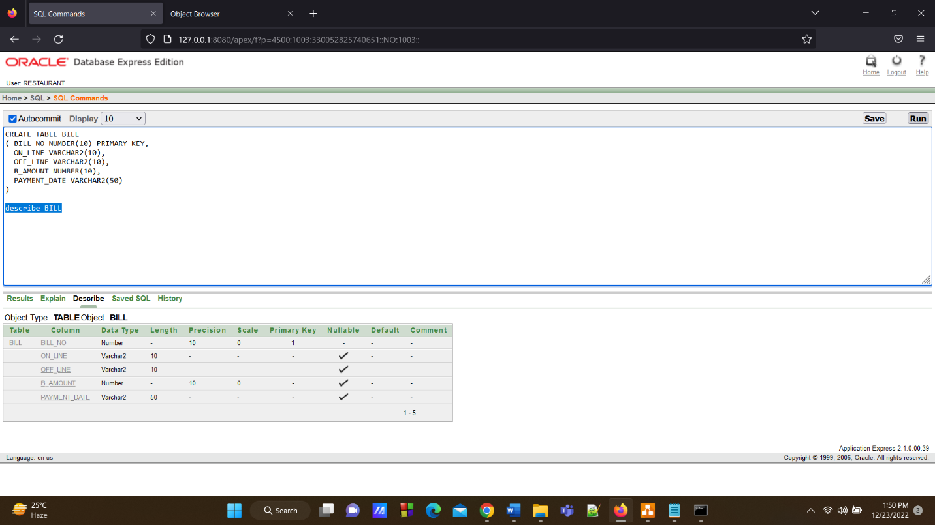

**19. Branch M Table**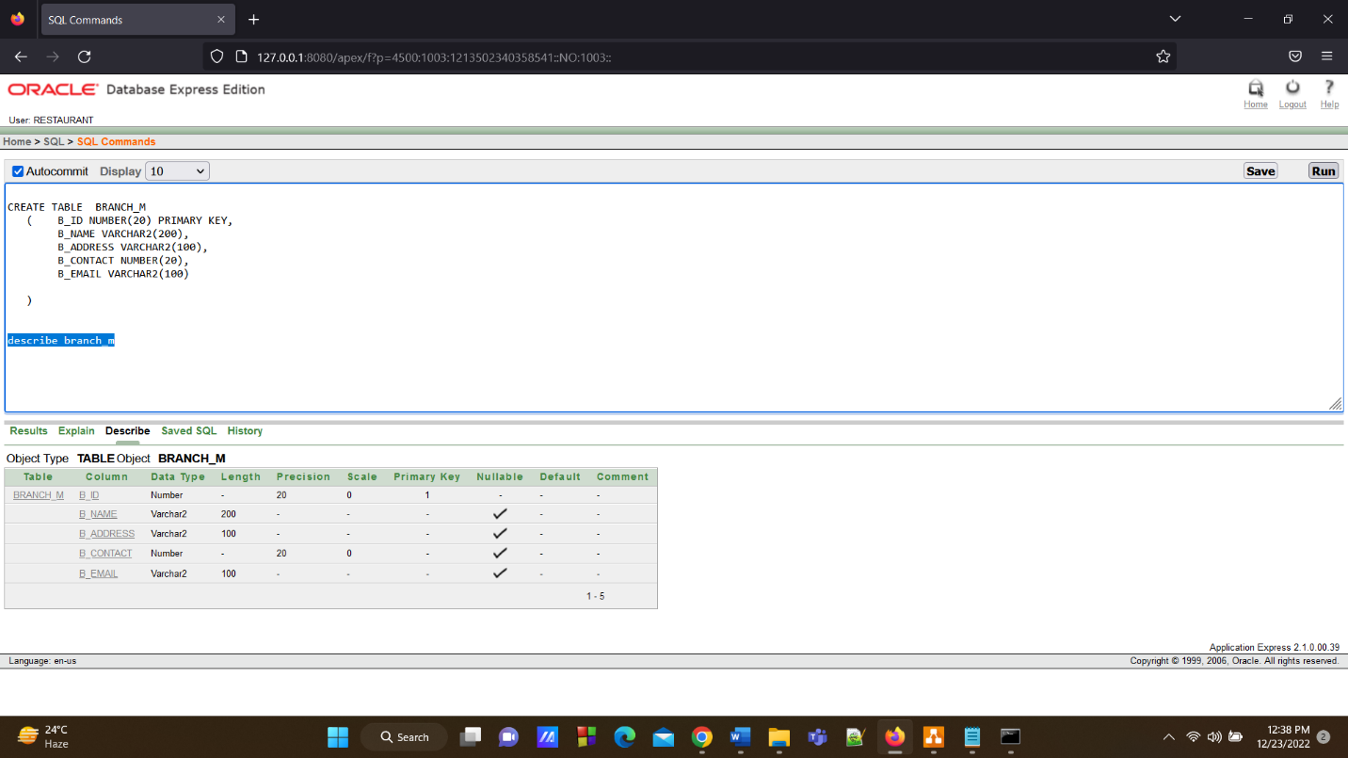

**20.Branch Customer Table**

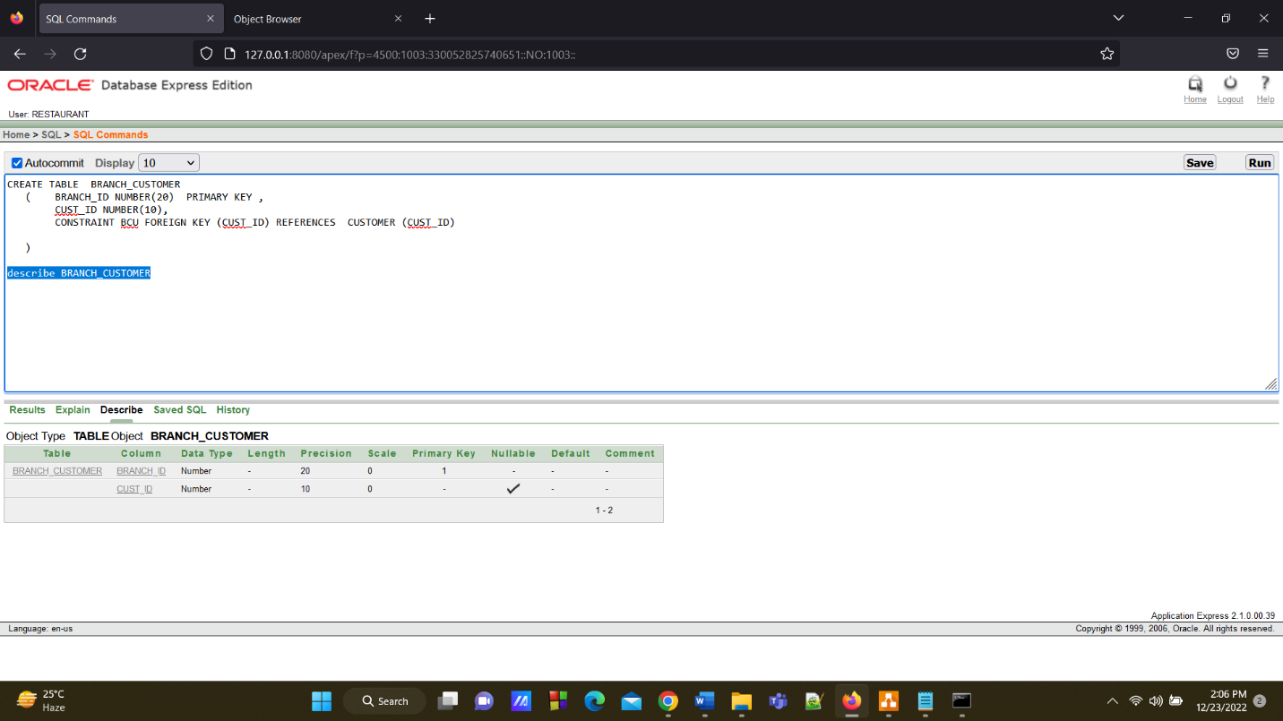

**Data Insertion**

**1.Main Restaurant Table**

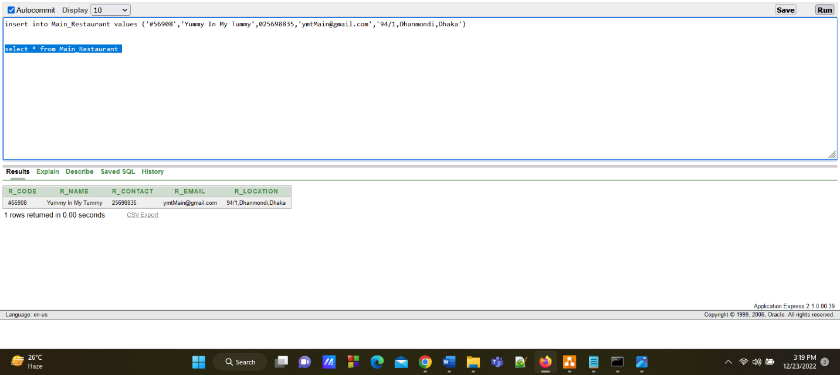

**2.Branch Table**

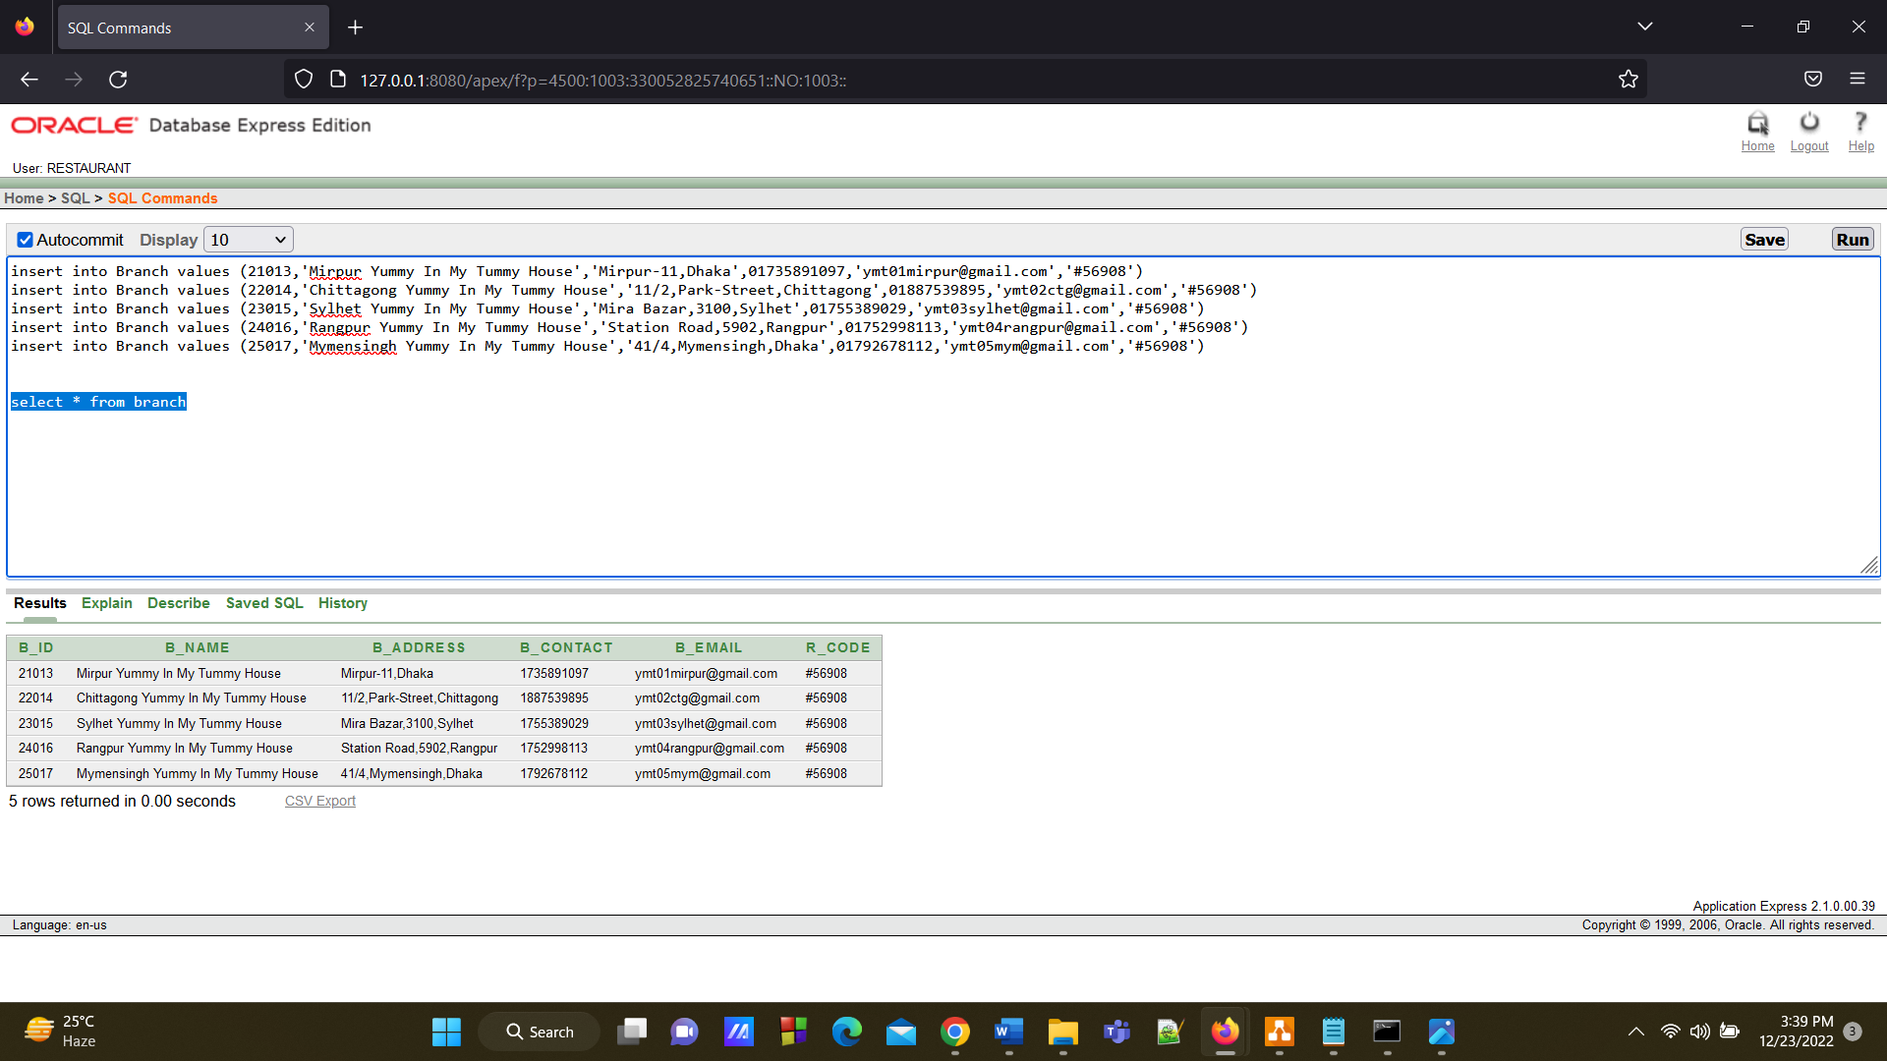

**3.Branch Staff Table**

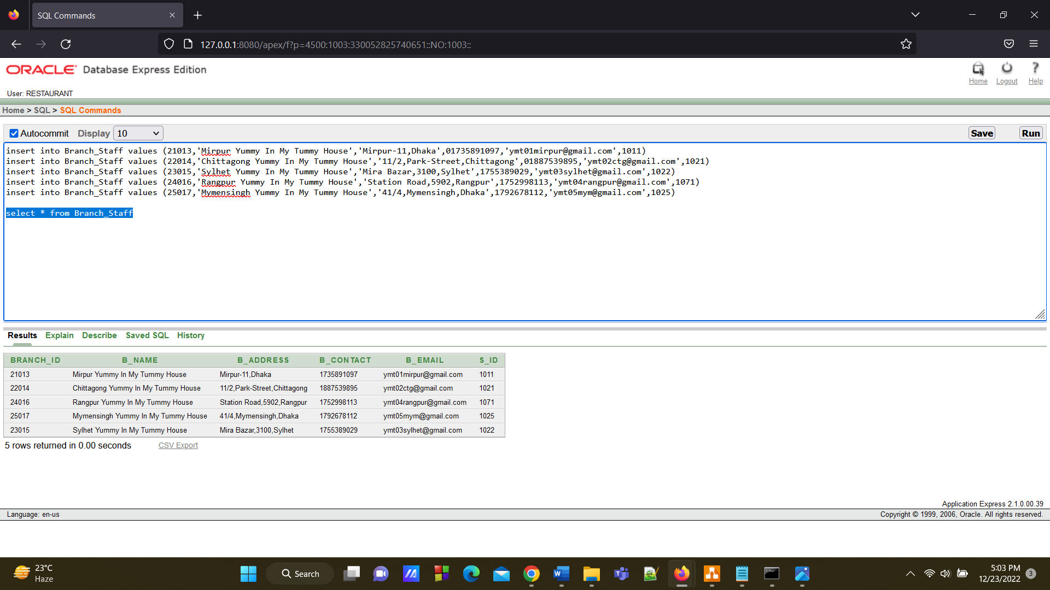

**4.Staff Info Table**

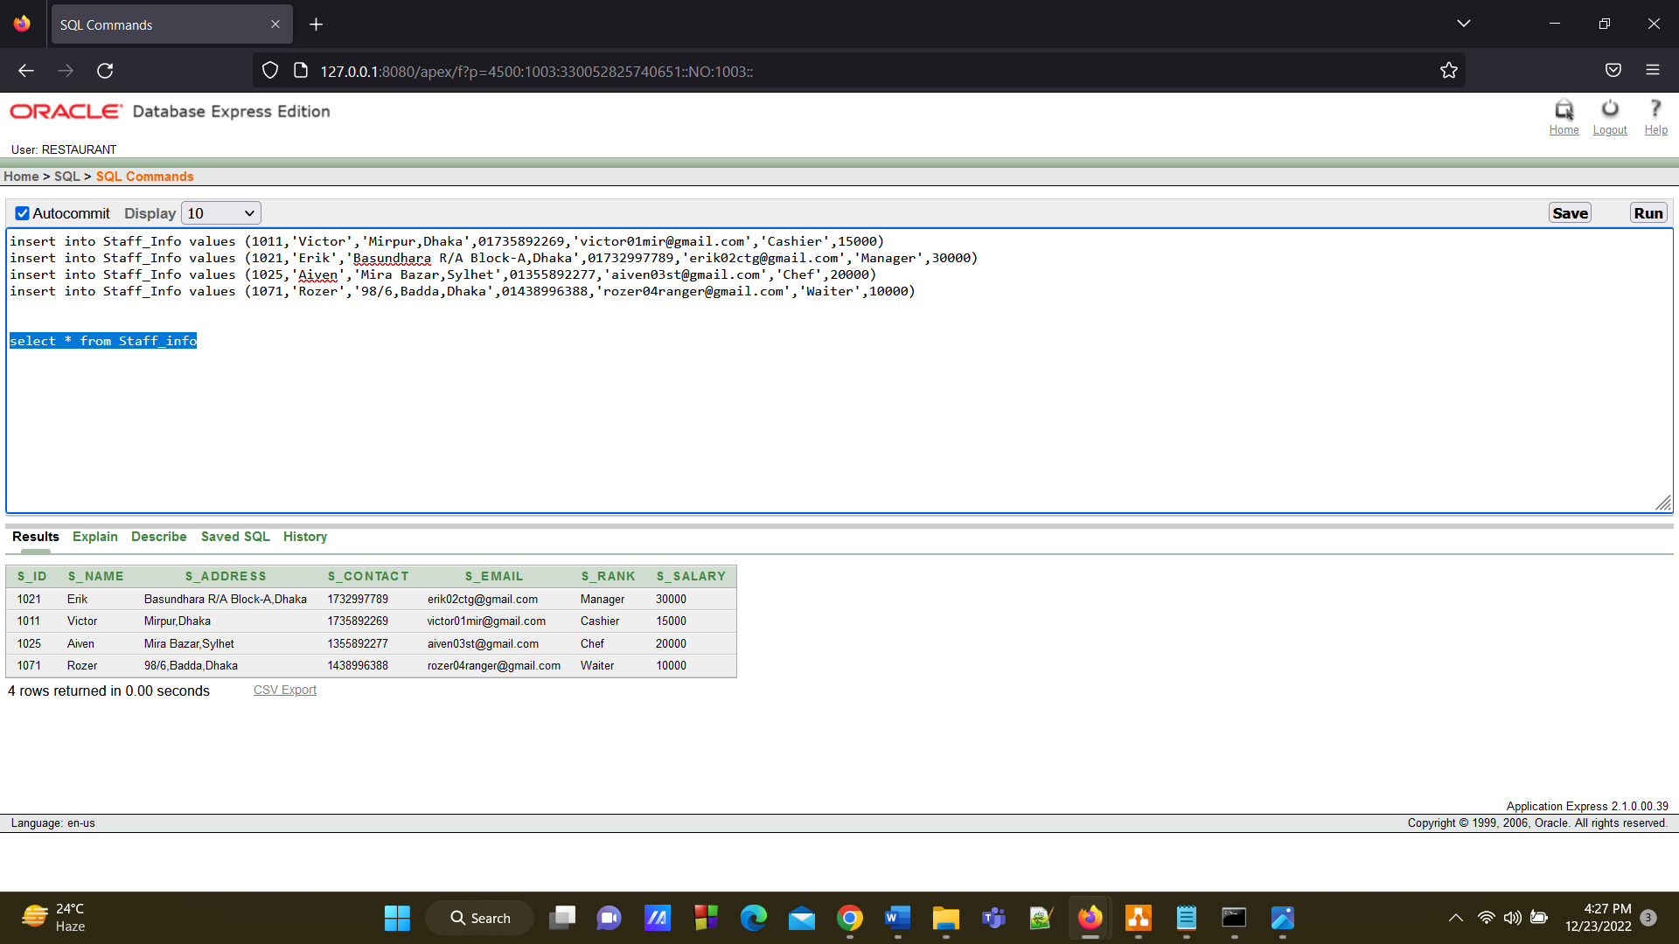

**5.Chef Table**

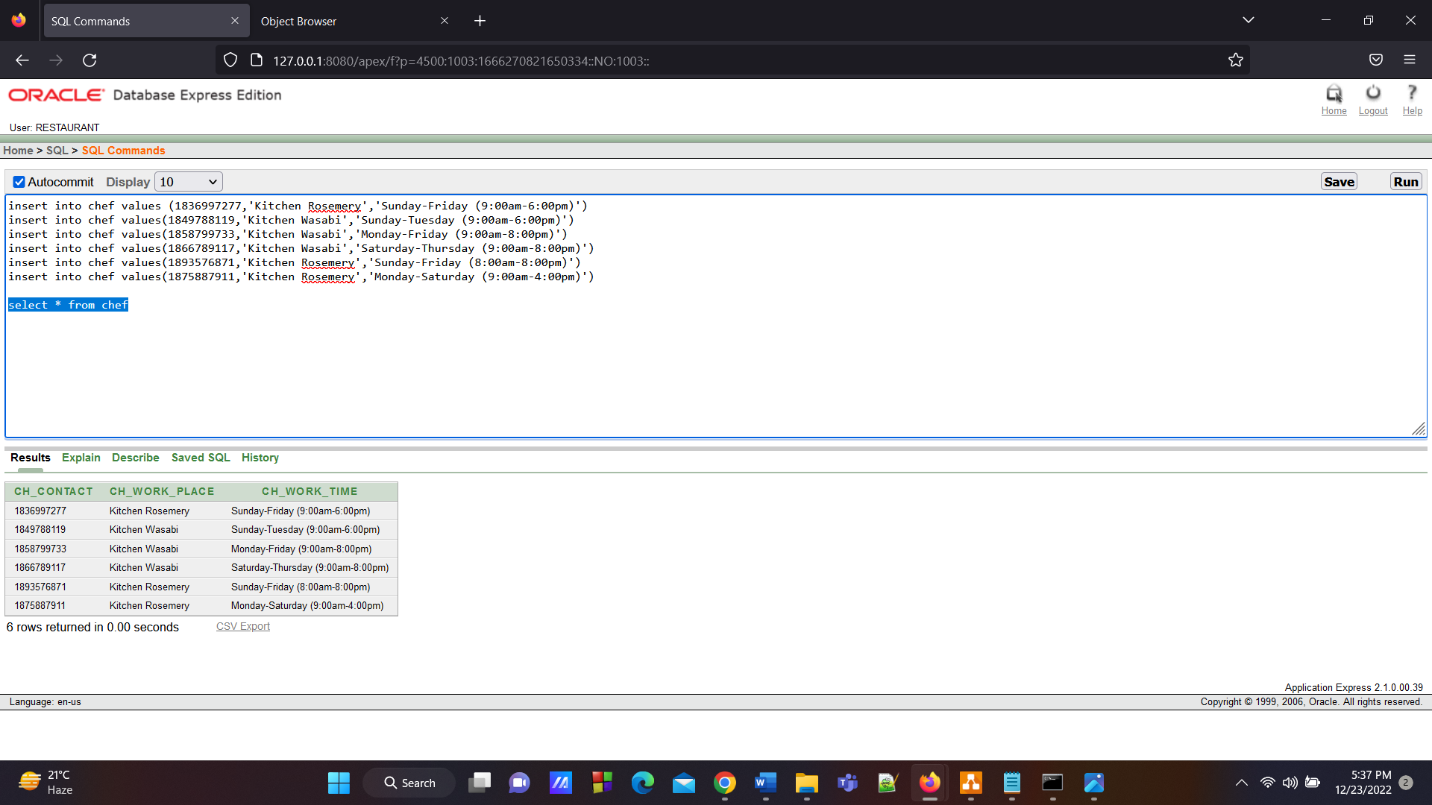

**6.Chef Belongs Staff Table**

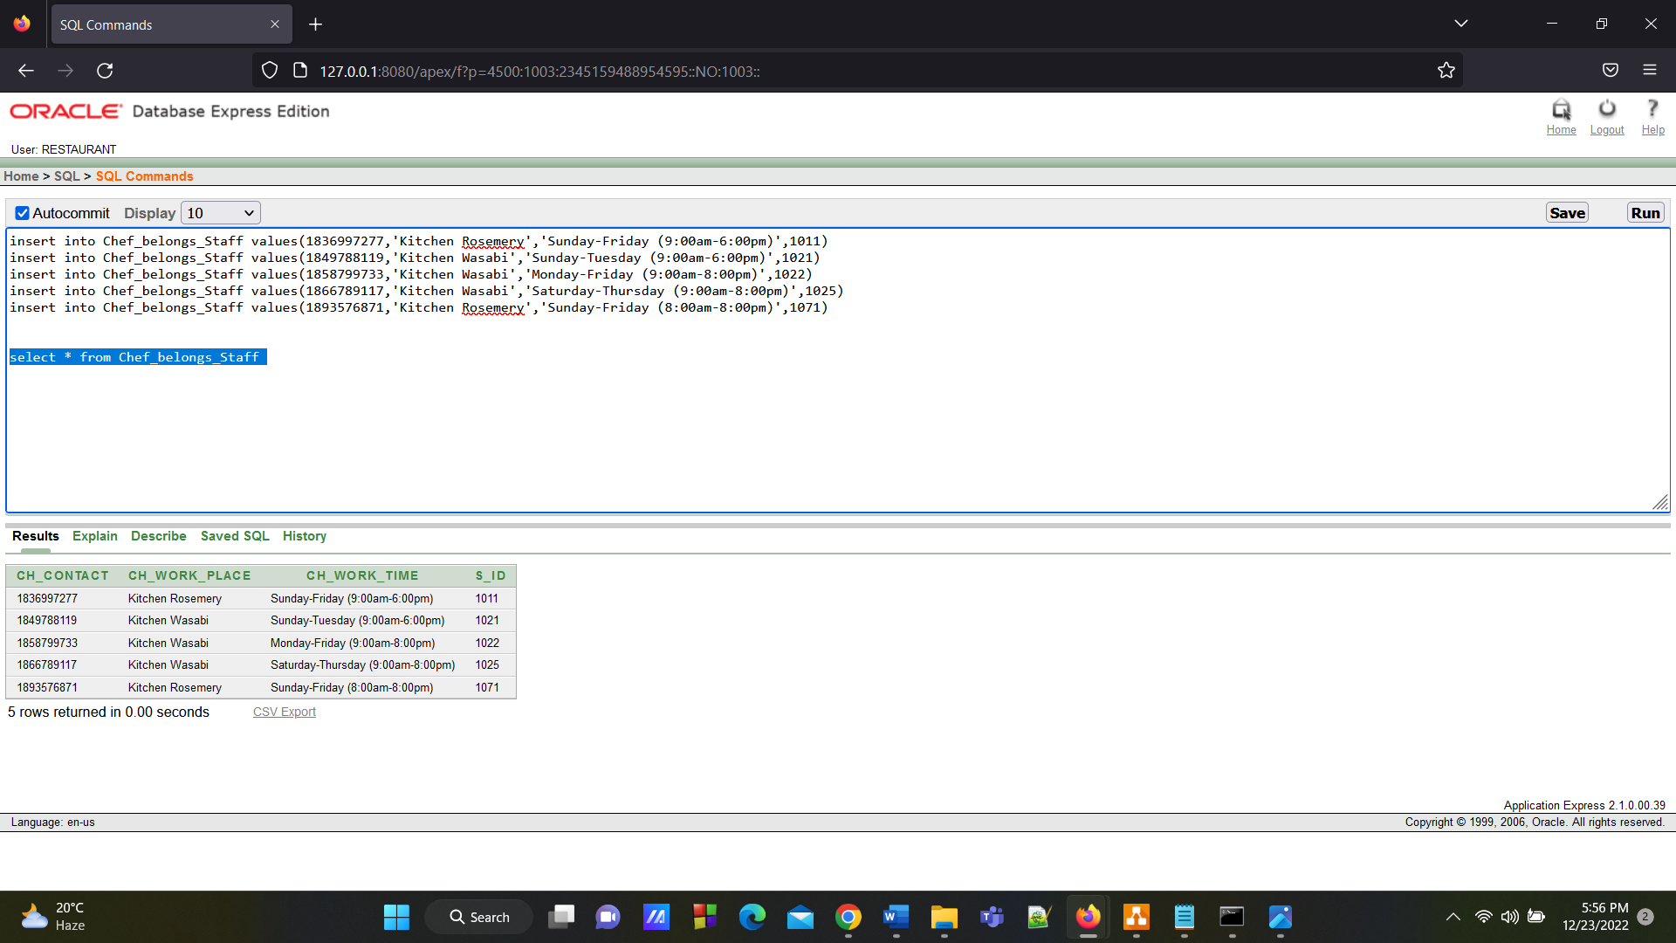

**7. Ingredient Table**

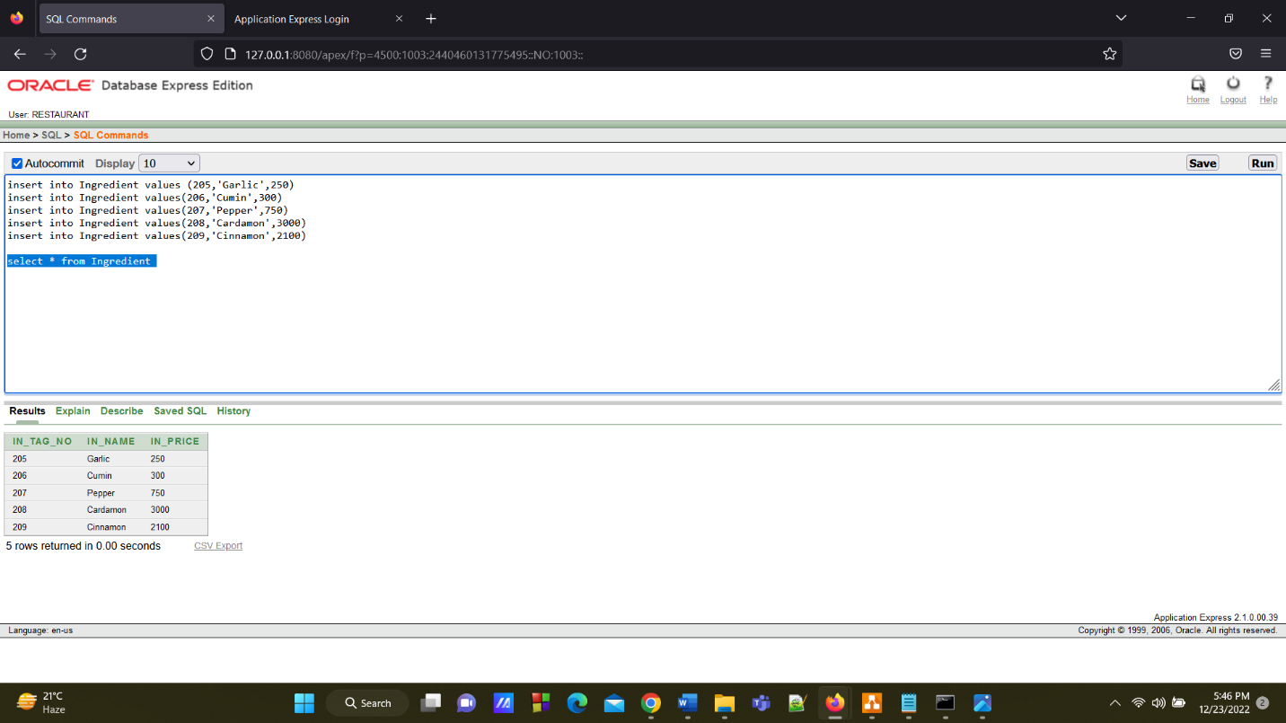

**8.Chef Ingredient Table**

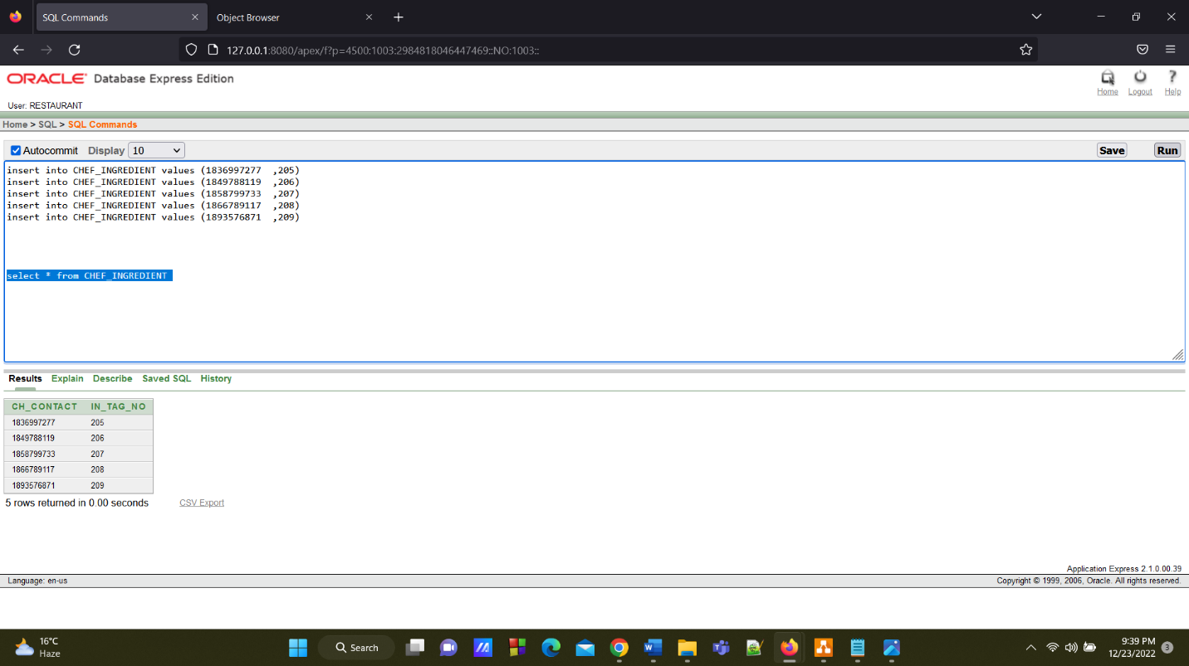

**9.Supplier Info Table**

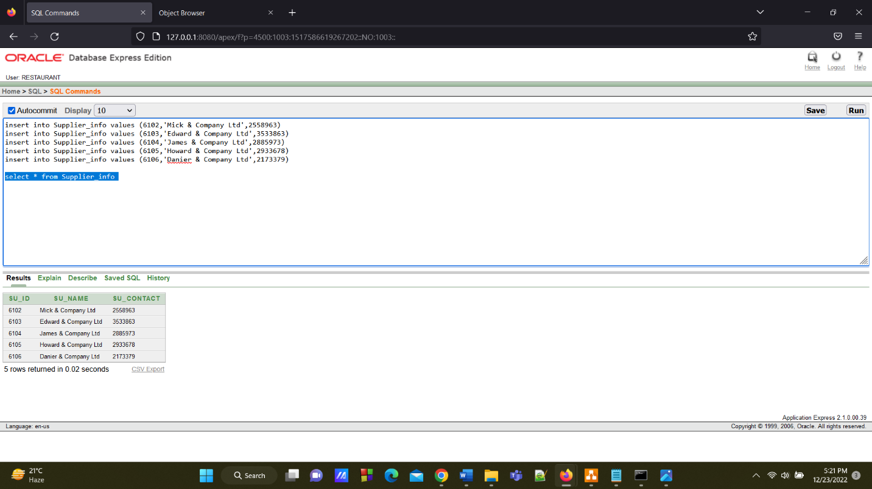

**10.** **Ingredient Supplier Table**

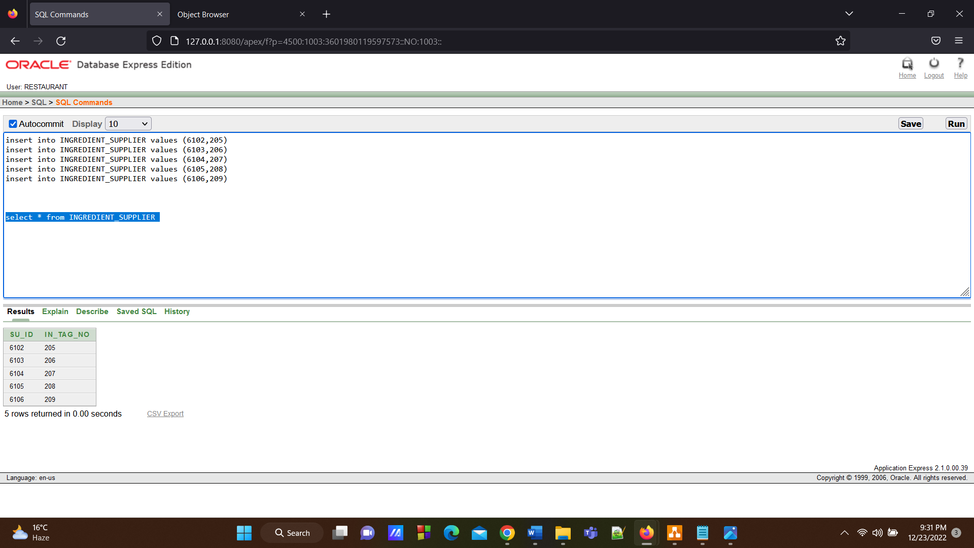

**11.Item Info Table**

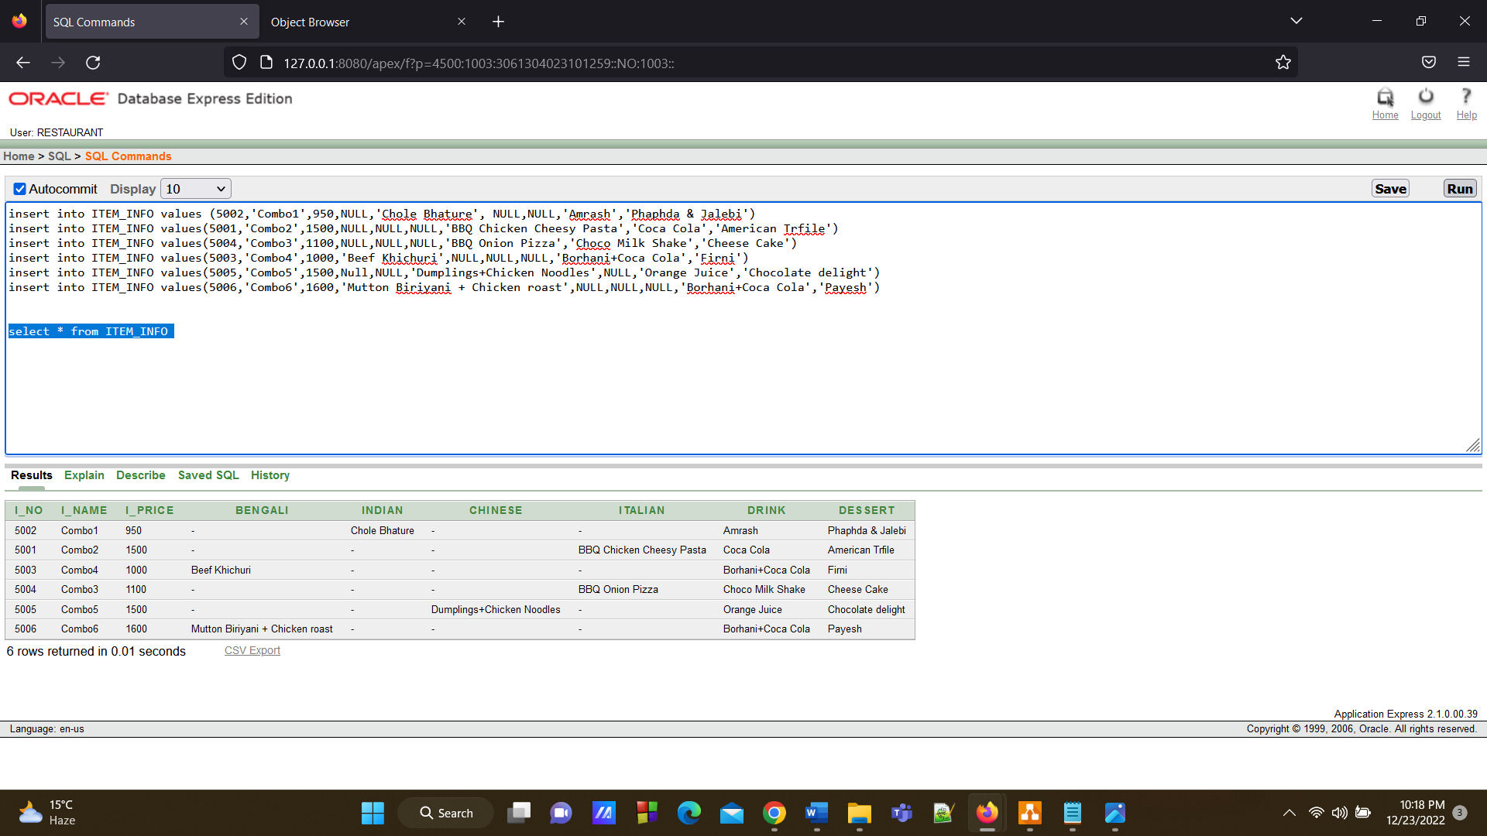

**12.Item Chef Table**

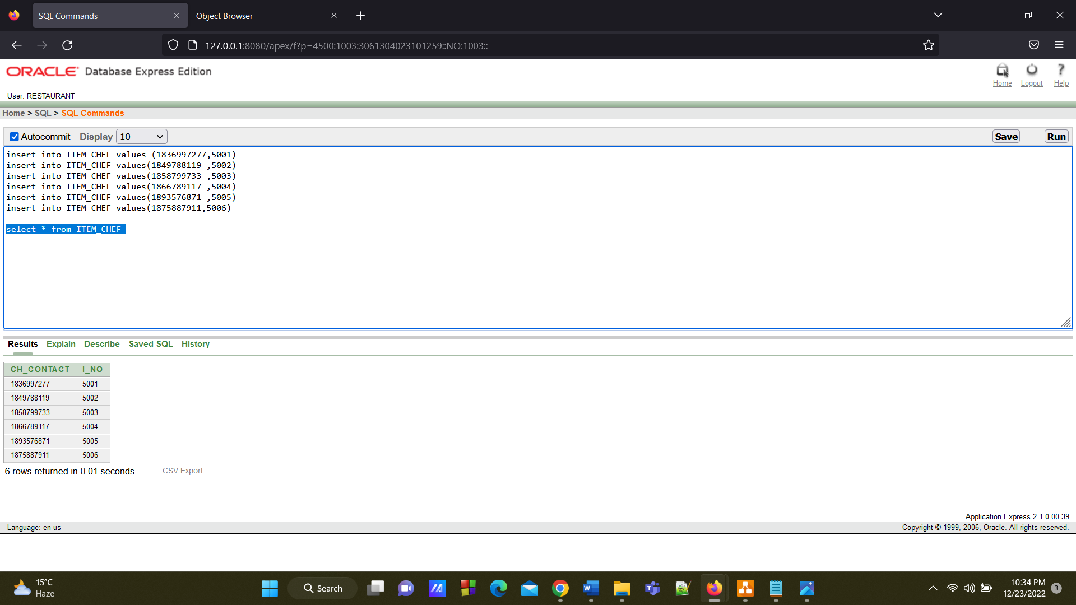

**13.Customer Table**

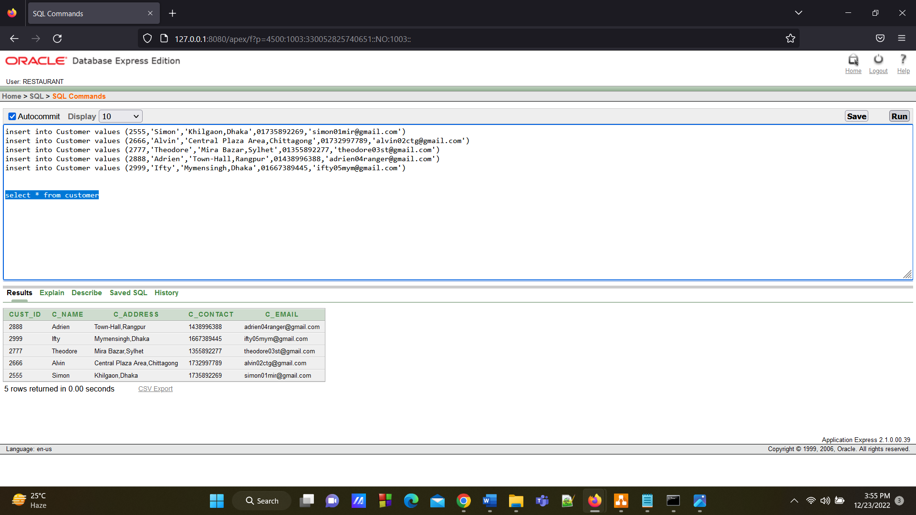

**14.Item Cust Table**

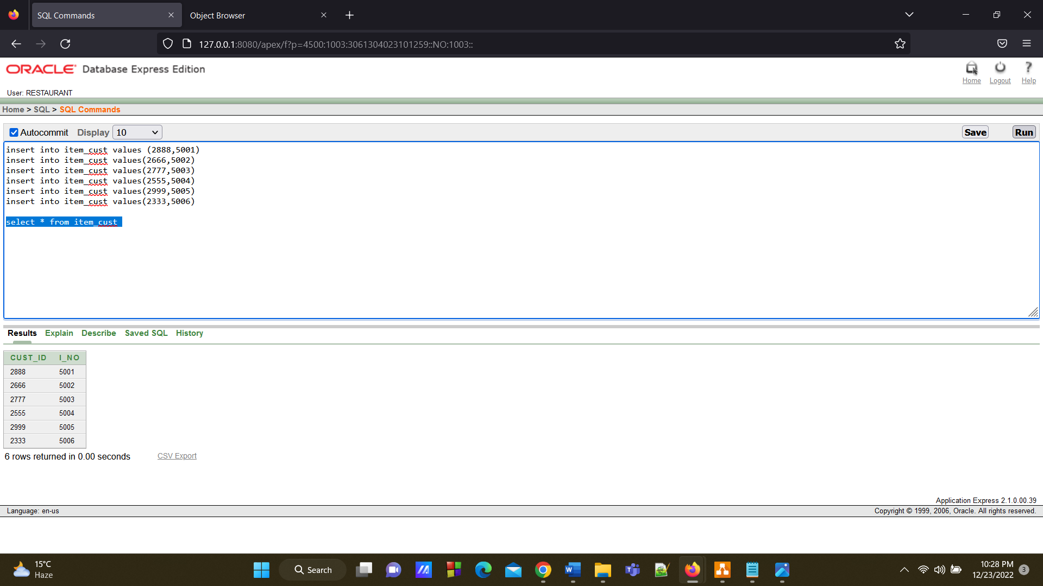

**15. Waiter Info Table**

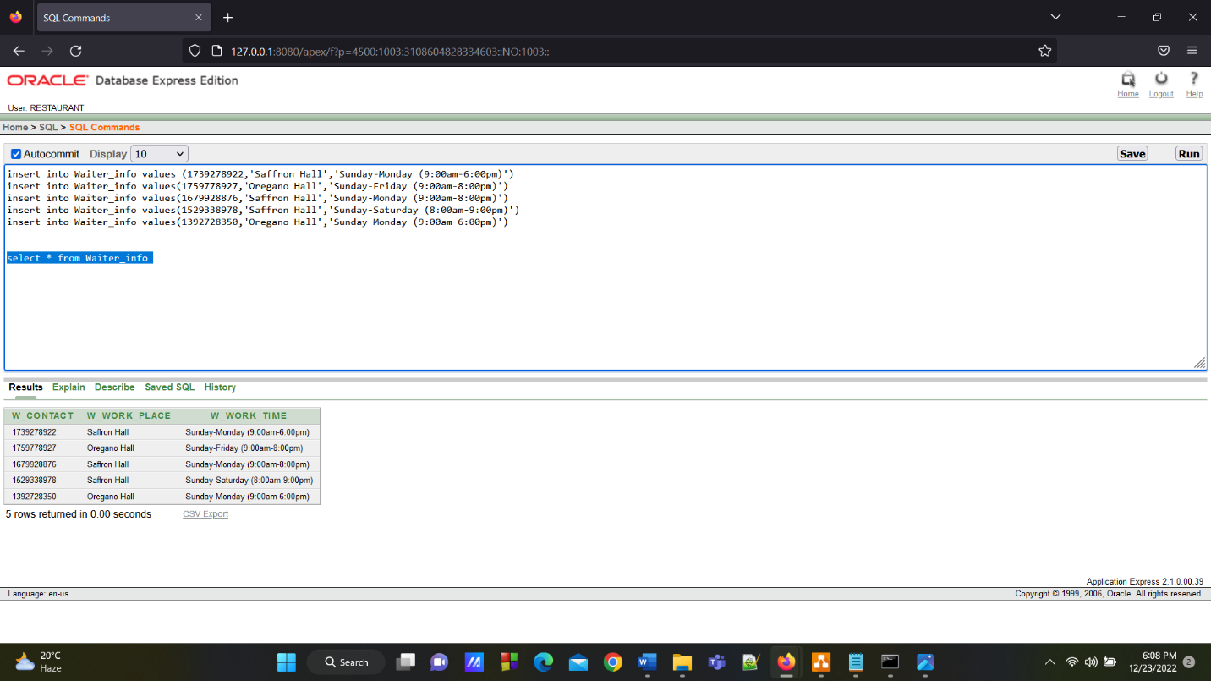

**16.Waiter Customer Table**

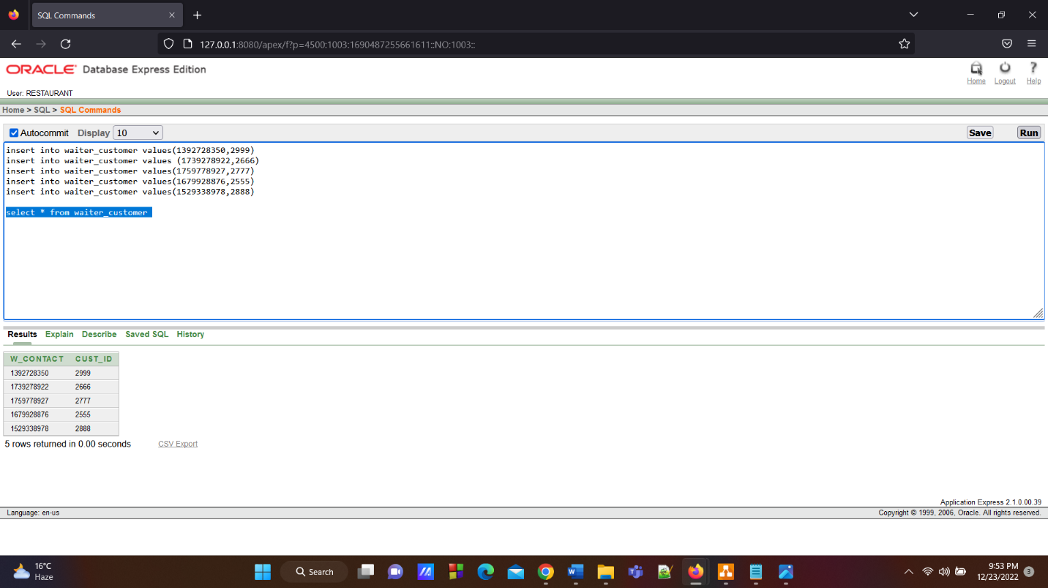

**17.Customer Bill Table**

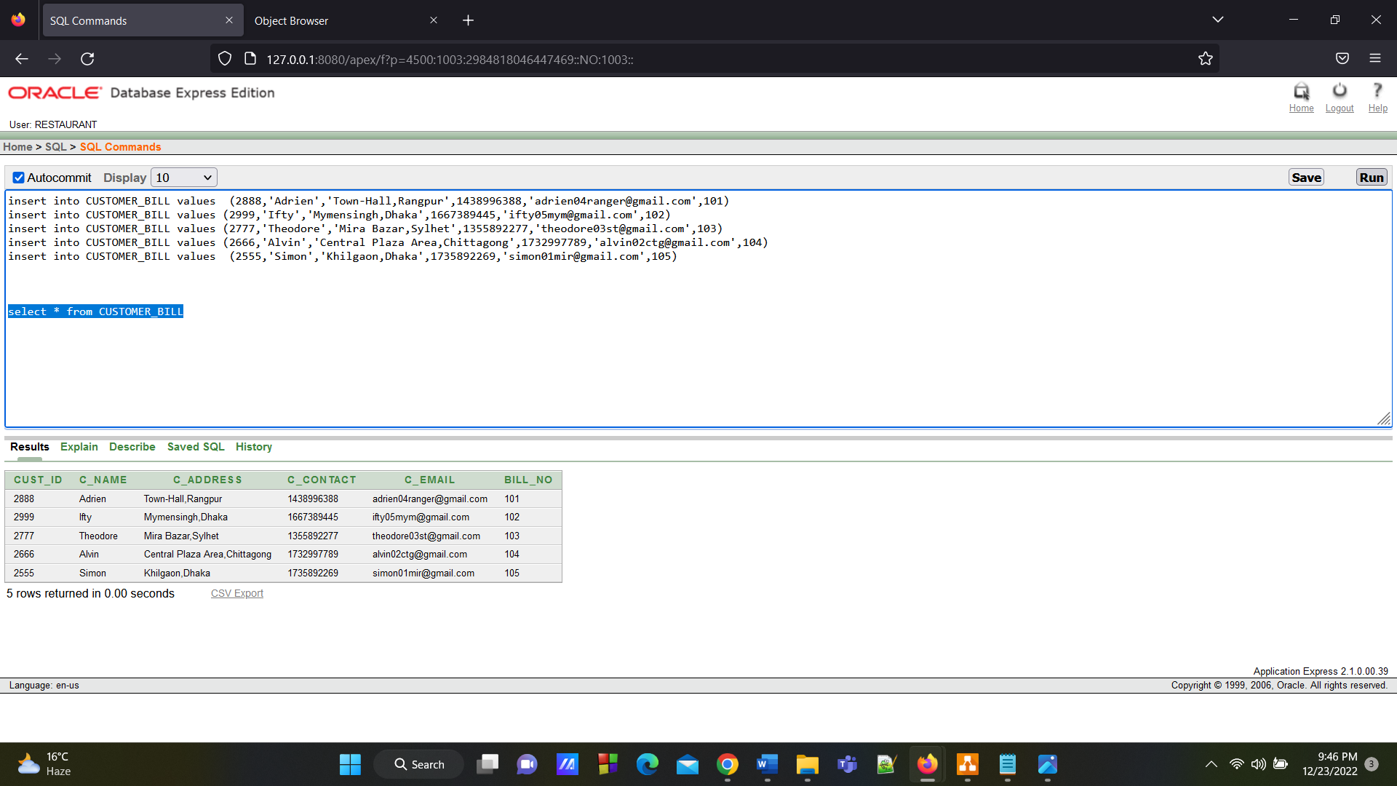

**18. Bill Table**

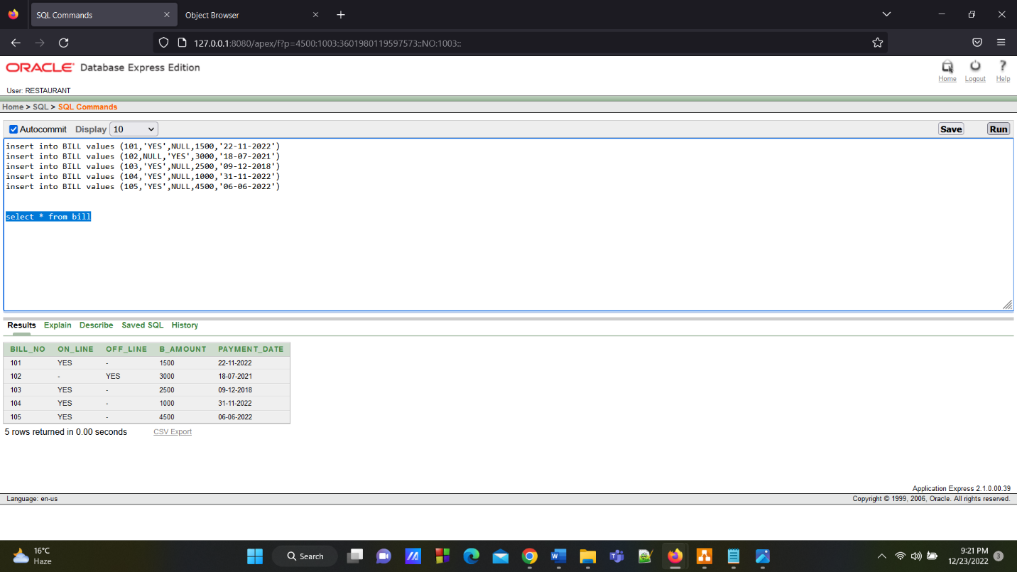

**19. Branch M Table**

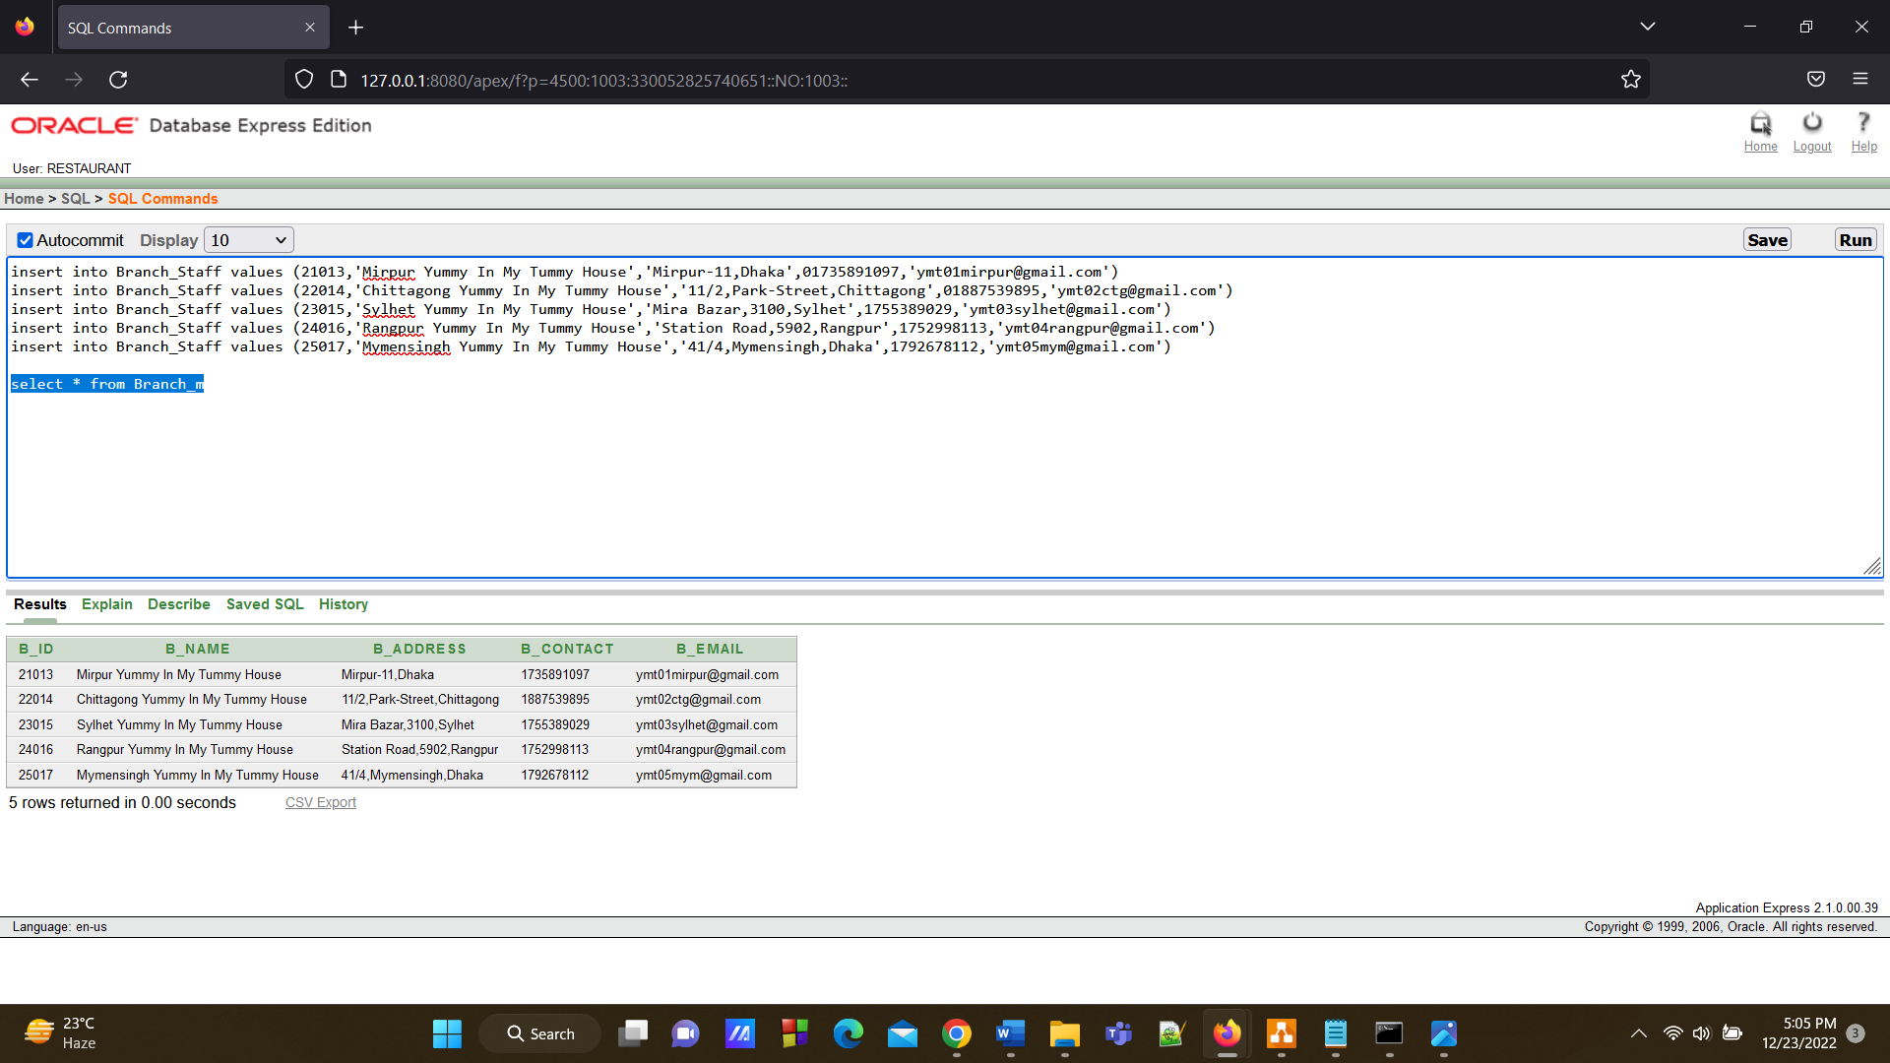

**20.Branch Customer Table**

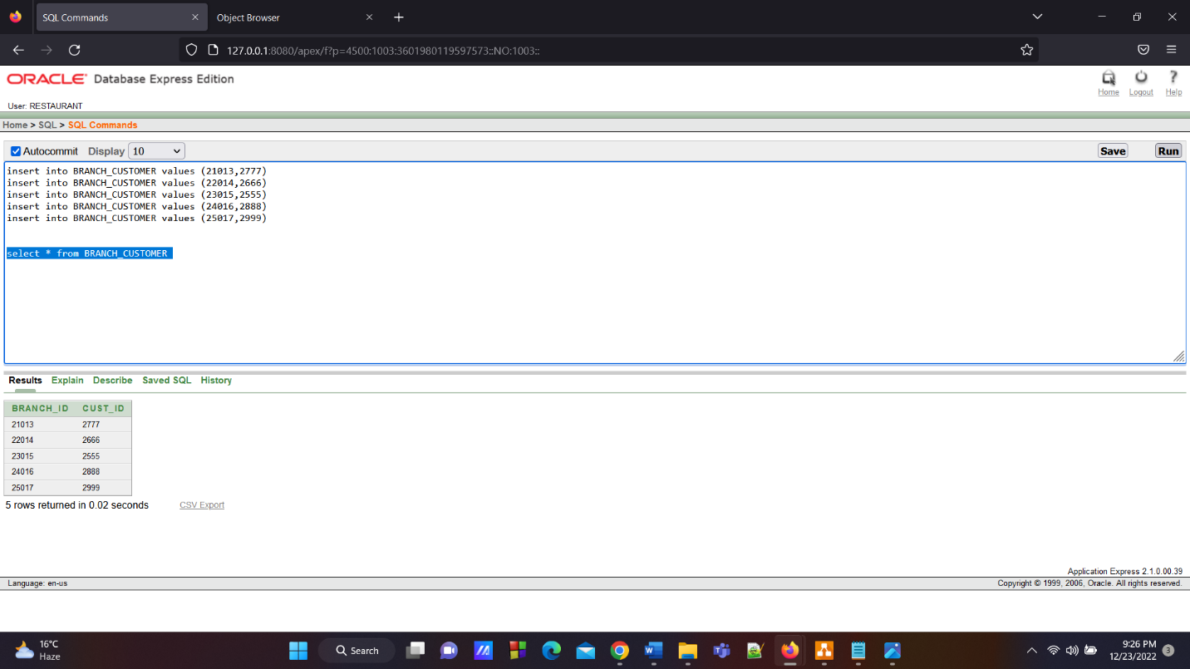

**Query Test**

**1.Single-row Function**

**Question:** **Display staff contact, staff name with address, length of staff rank and check the position of ‘n’ of staff name from staff info table where staff name is aiven.**

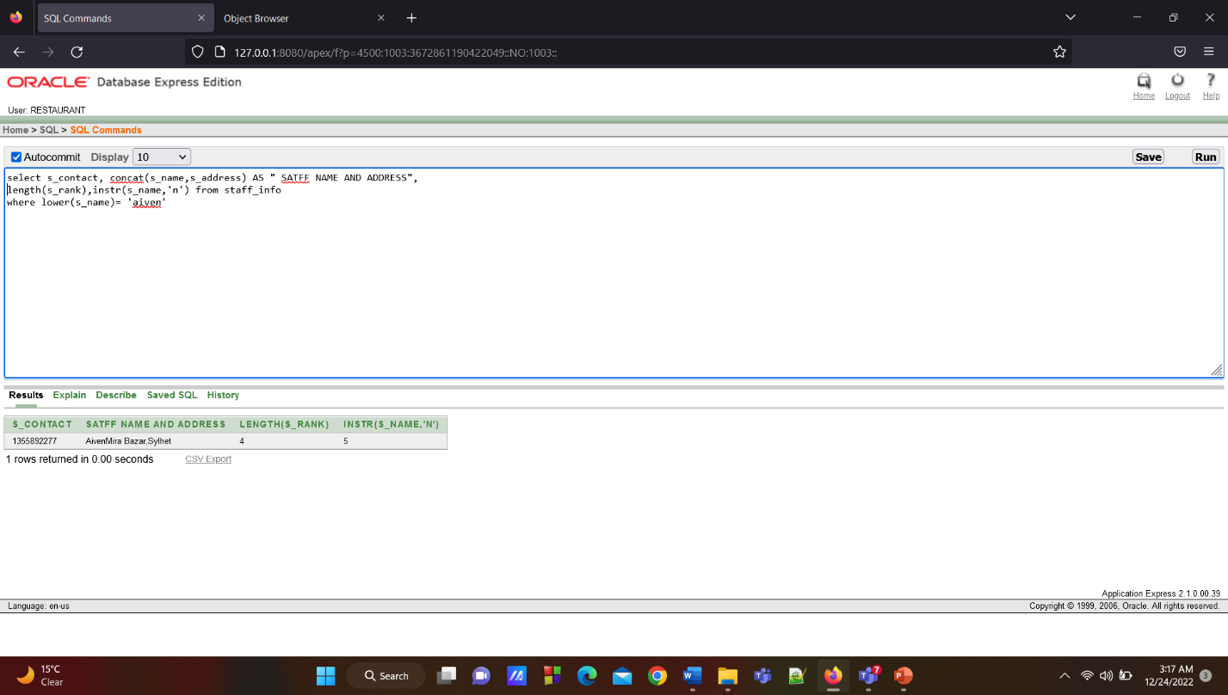

**2.Aggregate Function:**

**Question:**  **Display position and sum of salary as PRICE from Item Info table where dessert is not ‘PAYESH’ according to the order (default) of PRICE.**

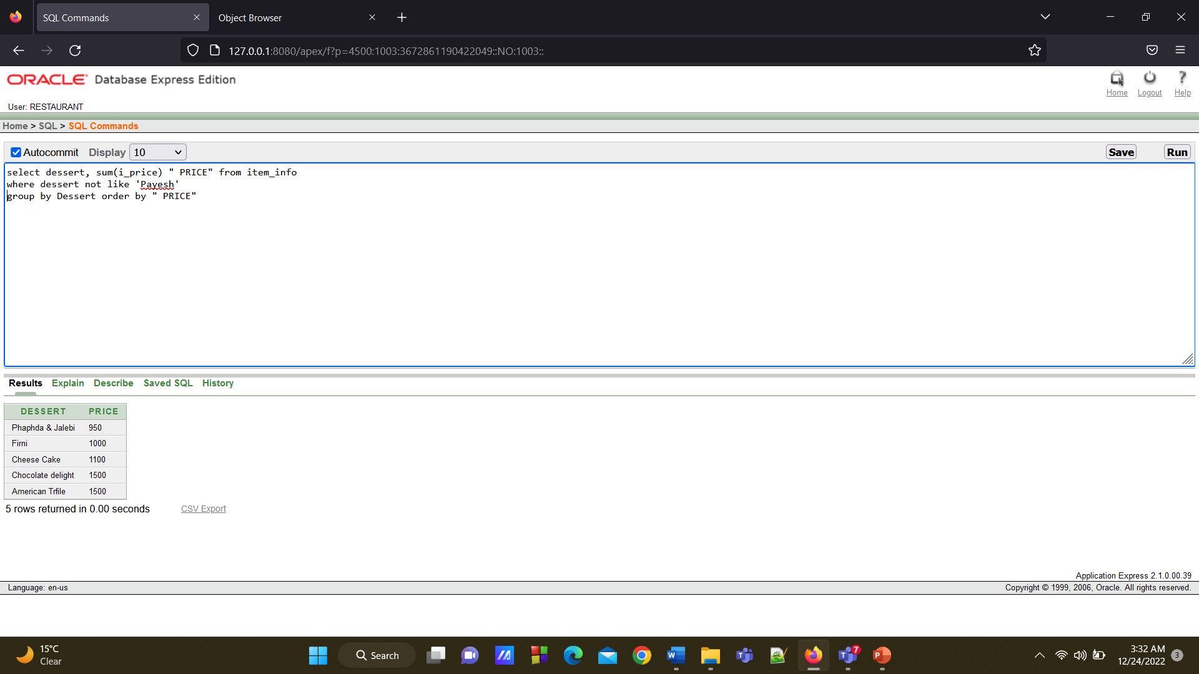

**3. Single-Row Subquery:**

**Question:**  **Display branch id and branch name from branch table where branch address is equal to branch contact no that is 1887539895 and branch id is equal to branch email ymt02ctg@gmail.com.**

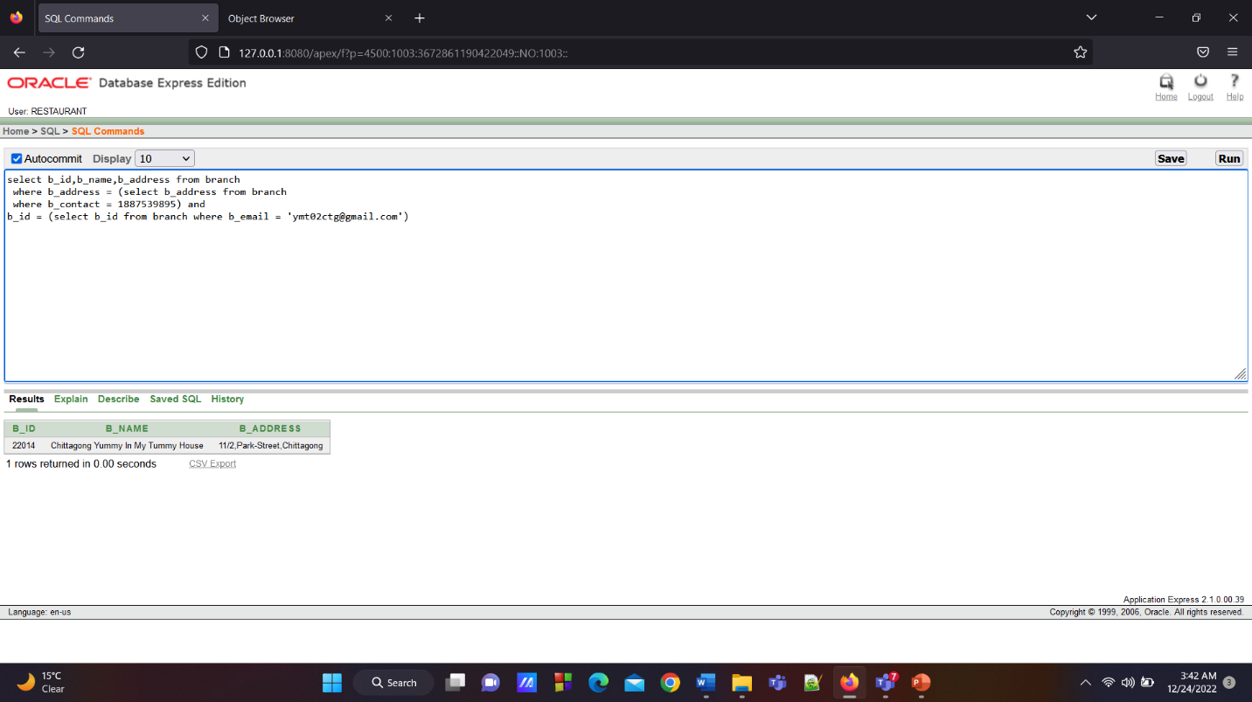

**4.Single-Row Subquery :**

**Question:**  **Display the record of chef contact, work time and work place columns from chef belongs staff table where staff id is greater than lowest number of staff id.**

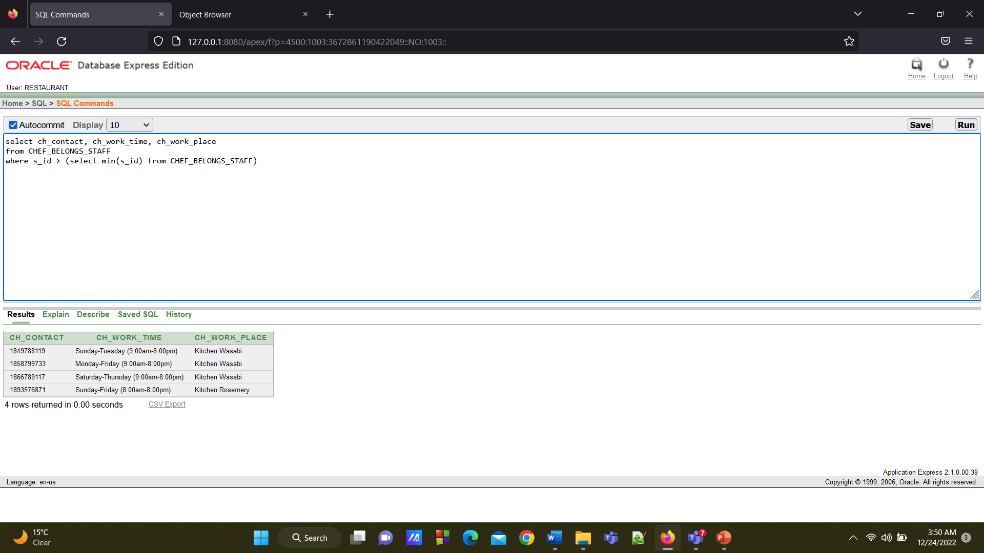

**5.Multiple-Row Subquery:**

**Question:**  **Display the record of customer id, customer name columns from customer info table whose contact number is 1667389445.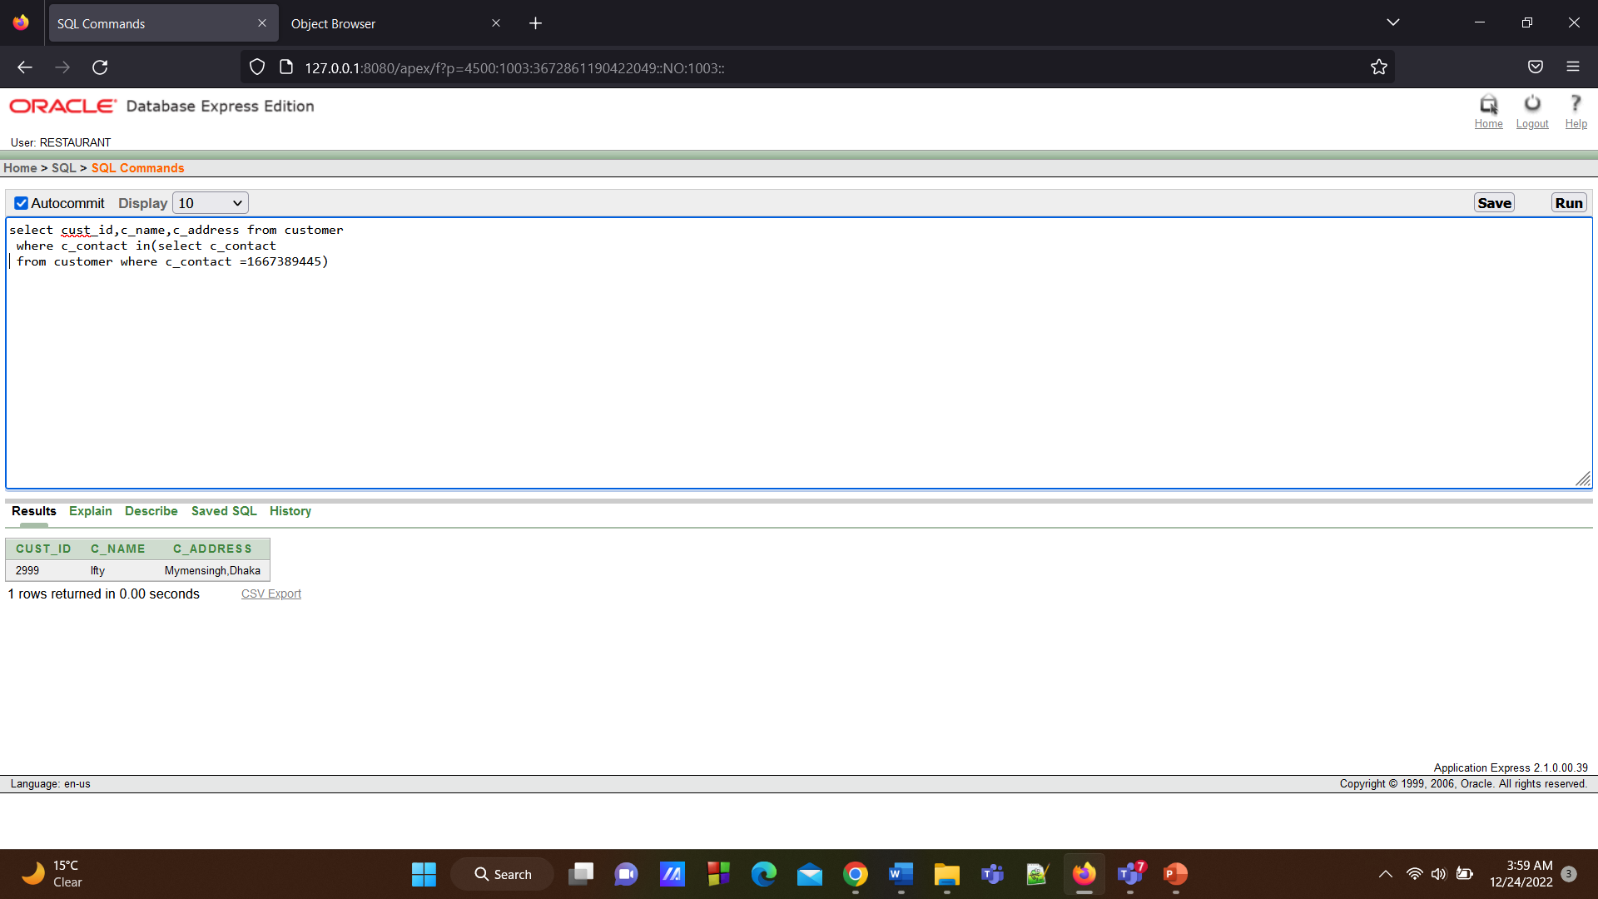6. Multiple-Row Subquery:**

**Question:**  **Display all the records of ingredient no, ingredient name, ingredient price columns from ingredient table where ingredient price is smaller than ingredient price which is equal to 2100 and ingredient tag no is not equal to 208.**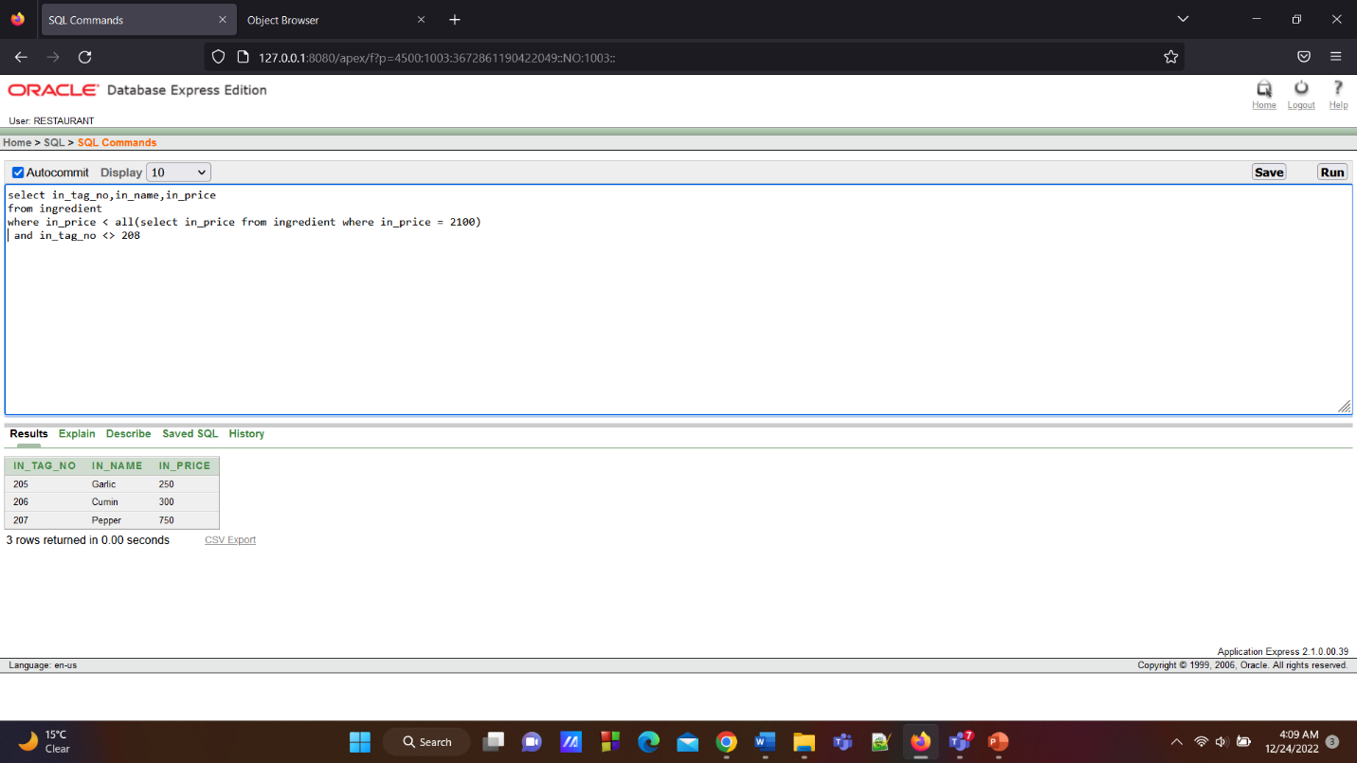

**7.Equijoin:**

**Question:**  **Create a join in chef belongs staff table and staff info table where the column of ch work place of chef belongs staff table and staff name of staff info table will be visible**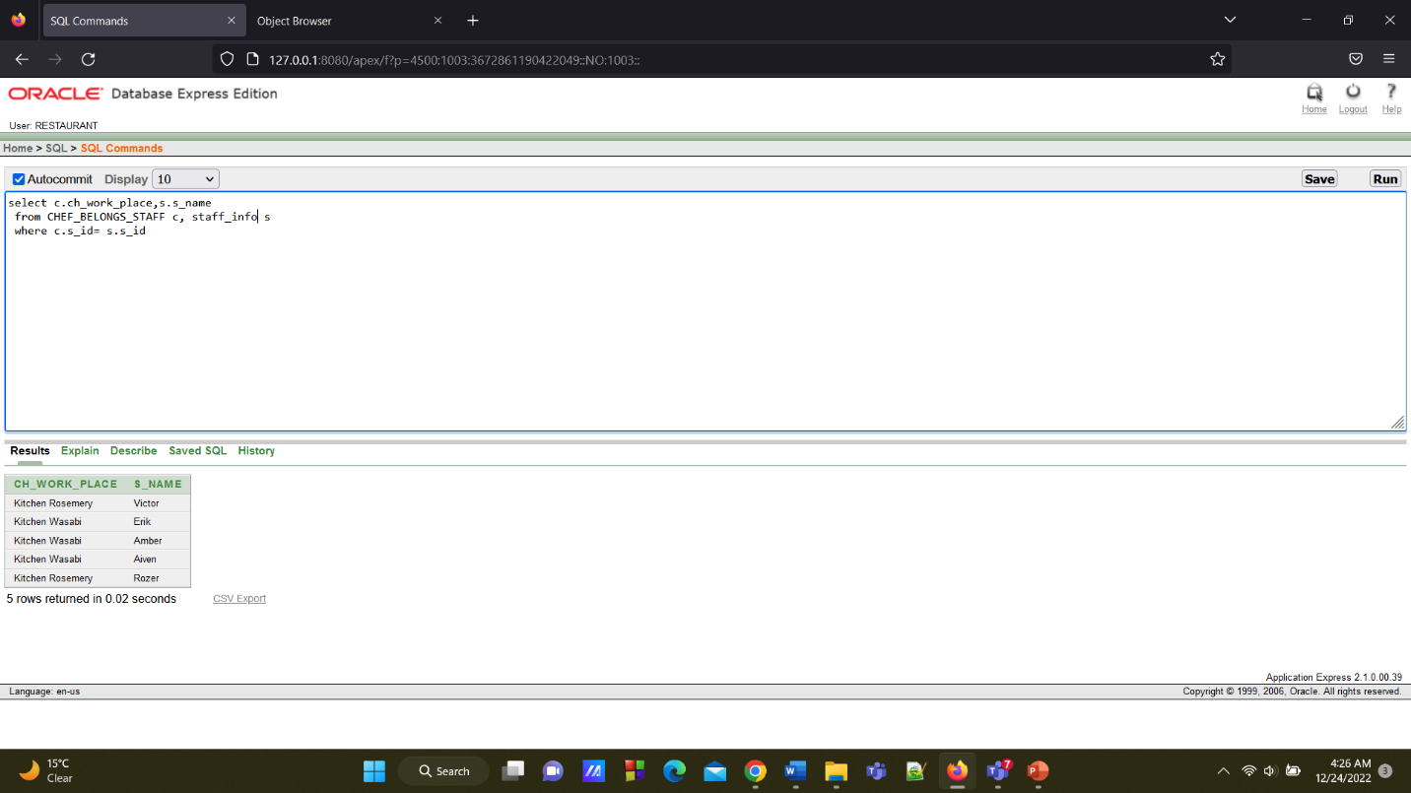

**8.Outer join:**

**Question:** **Write a query that will join the columns of chef contact of item chef table, item no and item name of item info table. No rows of the item table will be missed.**

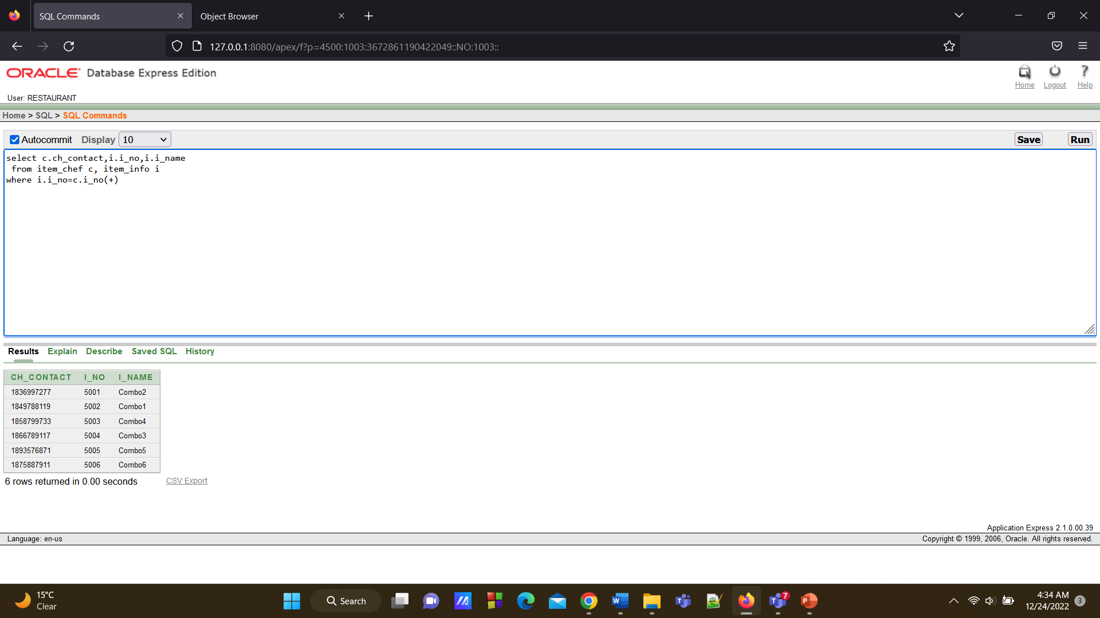

**9.Self join:**

**Question: Write a query to display name and price of ingredient that will matches ingredient those have same price.**

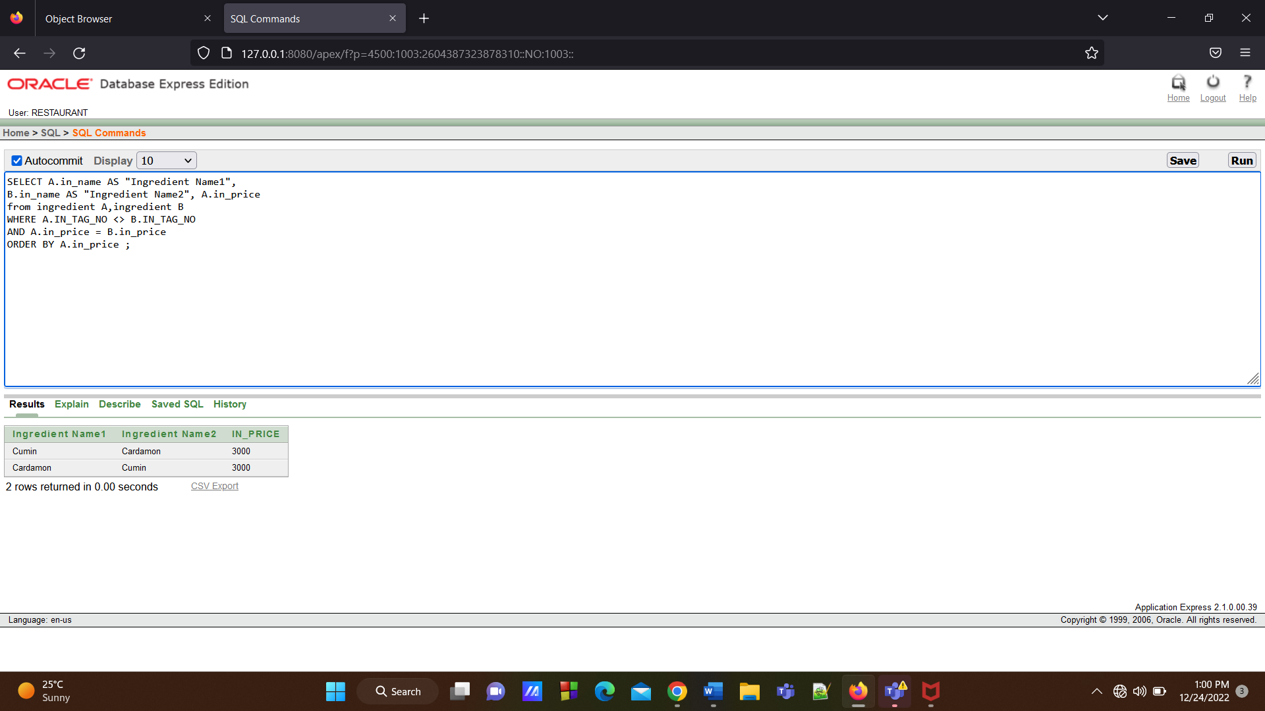

**10.Self Join:**

**Question: Write a query to display name and address of staff that will matches staff who have same amount of salary.**

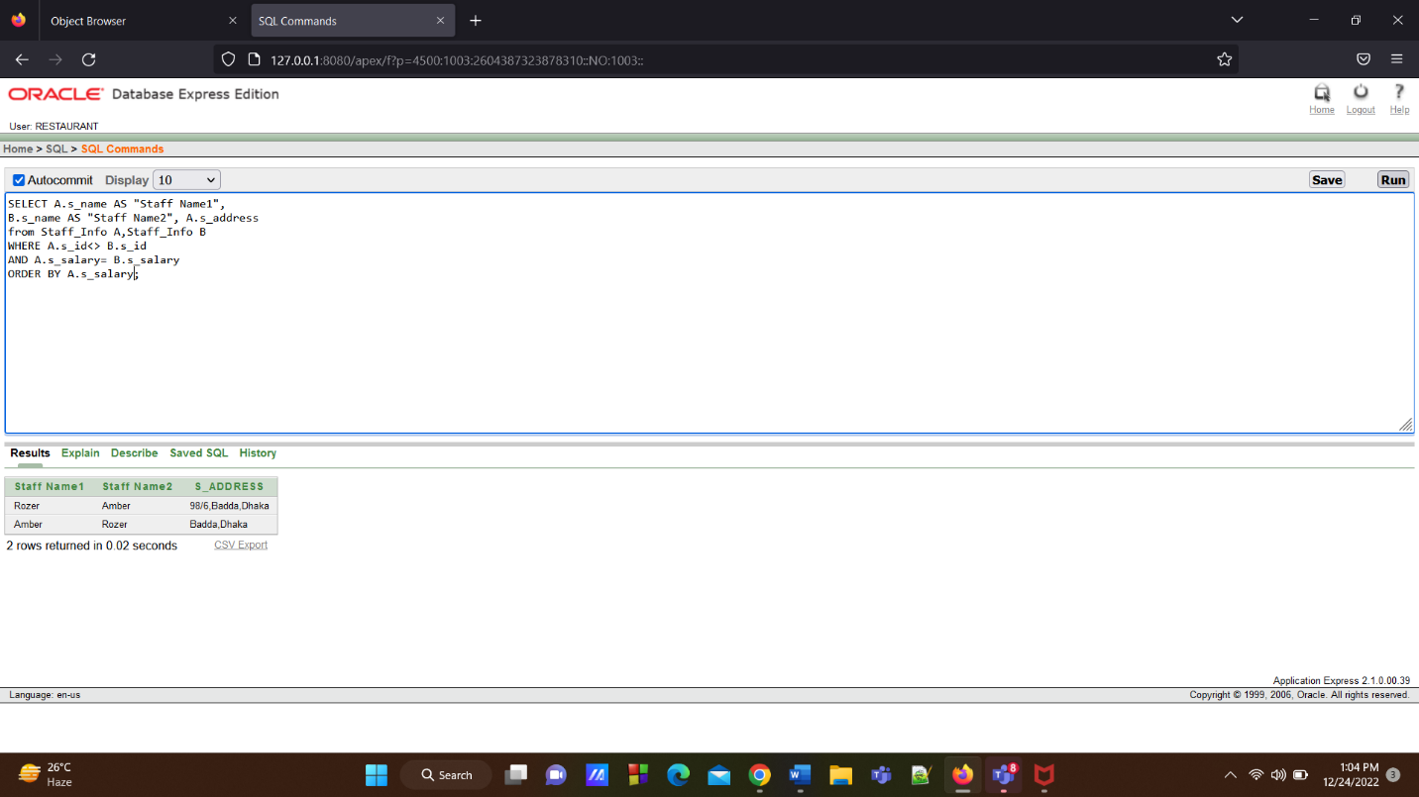

**View**

**1.Question:** **Show the view from Item Info table where the price of items is greater 1800 for column item no, dessert and Bengali items**

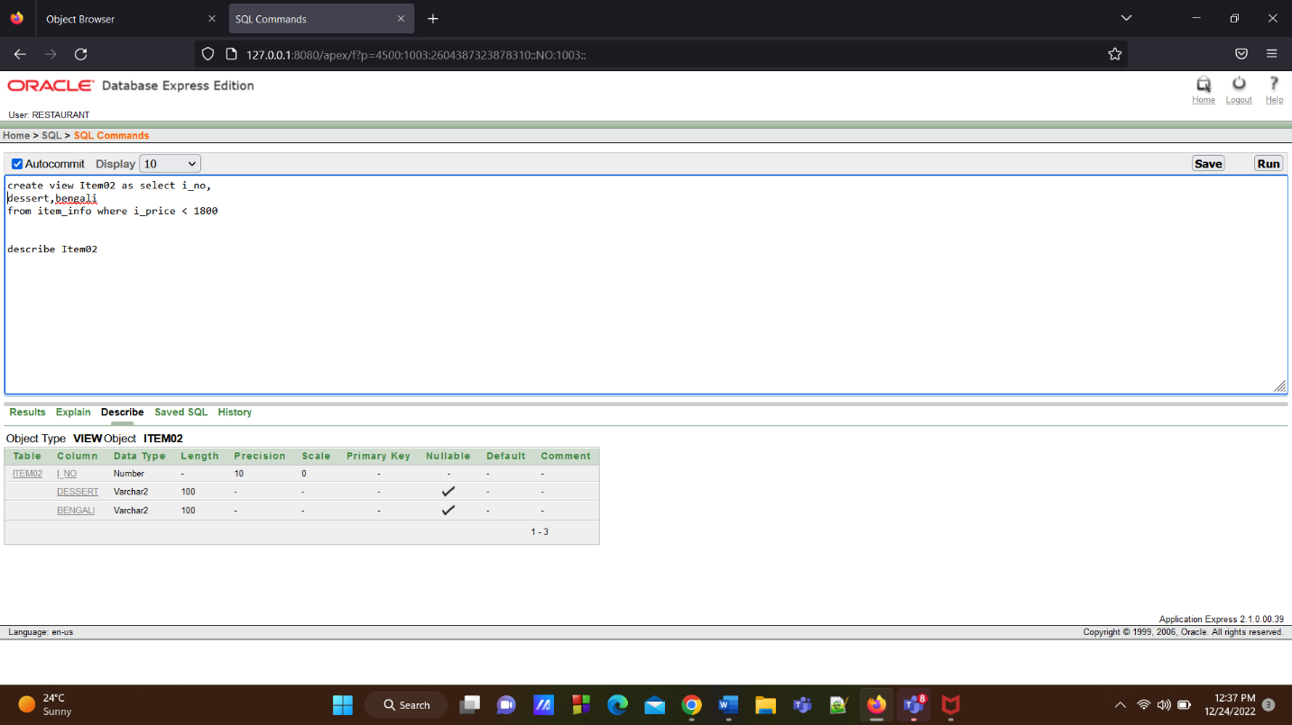

**Show view**

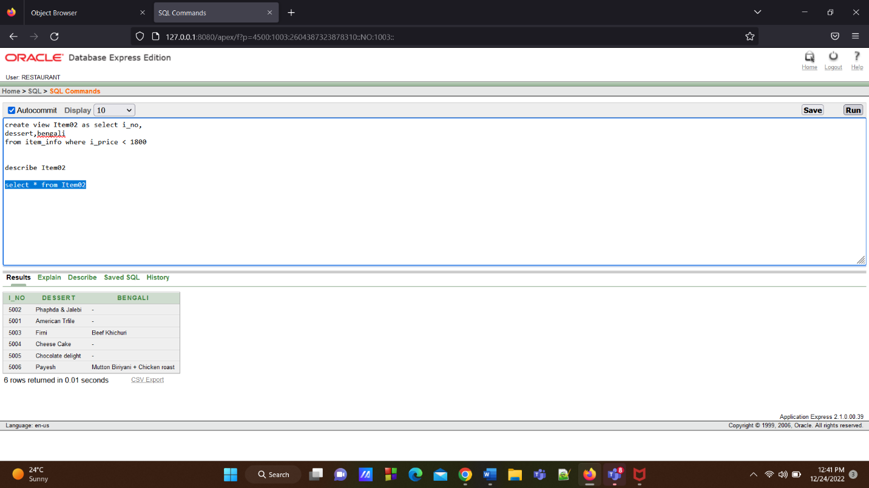

**2.Question: Show a view of staff and branch where staff and branch are at same location.**

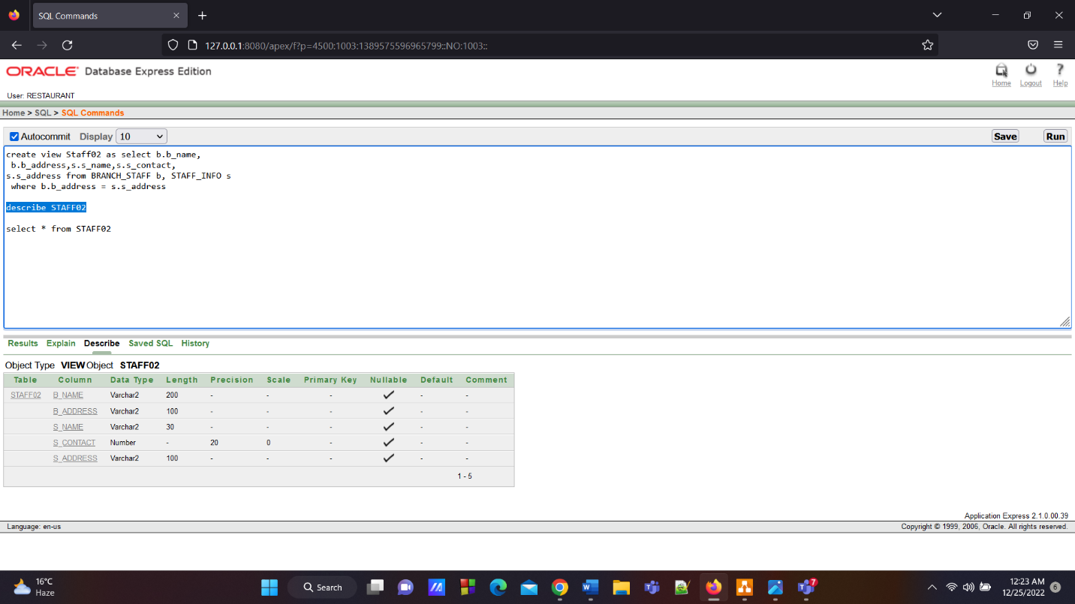

**Show view:**

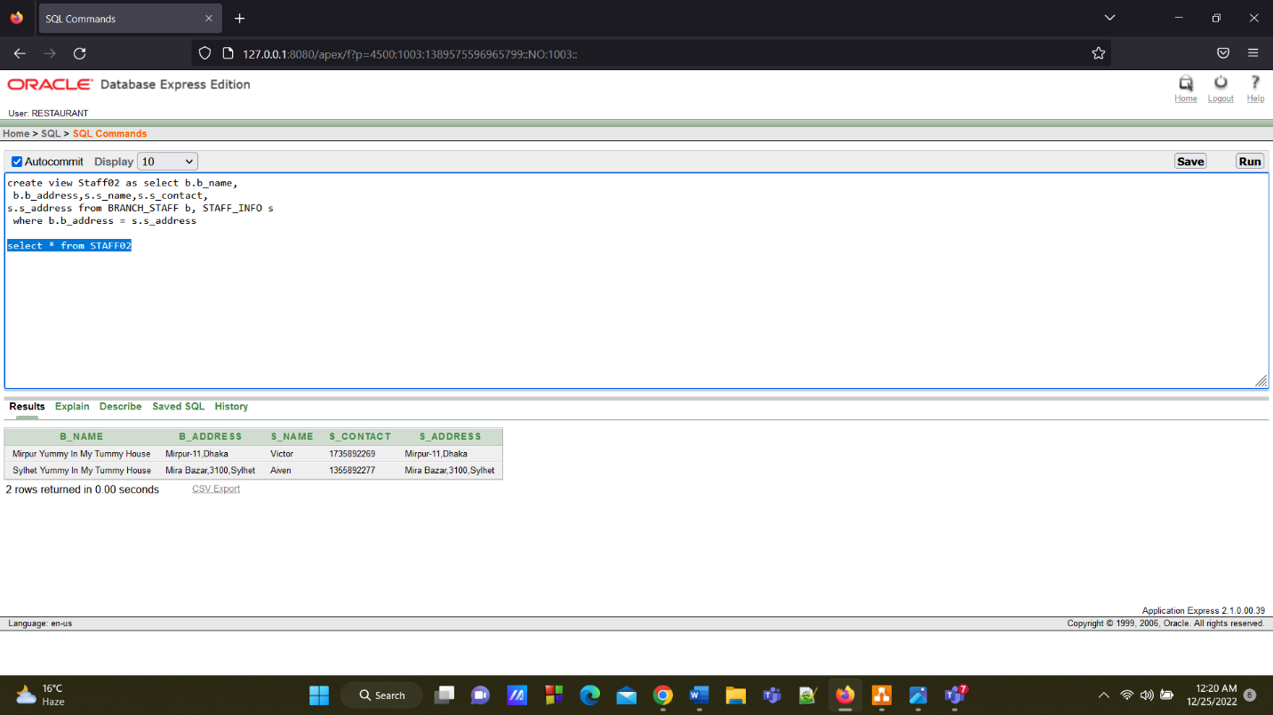

**Conclusion**

The term restaurant describes an establishment that provides healthy, hygienic, inexpensive and delicious food items to customers with well-maintained staff system. To maintain restaurant related work easily we have made this restaurant management system. Our database management system is designed for those who love to eat delicious food but can't prepare it at home, to serve food easily to those who are busy, away from home and don't have time to prepare food. In our management system online delivery order system is not started yet. We will try to develop it and try to add this feature in our restaurant management system in the future.